PART TWO
COMBAT IN TOWNS
CHAPTER 1
CHARACTERISTICS
SECTION I
GENERAL
64. REFERENCES. For the general characteristics of combat in towns and the principles governing offensive and defensive combat, see FM 100-5. For methods of offensive and defensive combat by infantry units, see FM 7-10, 7-15, 7-20, and 7-40.
65. PURPOSE. The purpose of Part Two is to state the application of the fundamental doctrine and tactical principles of offensive and defensive combat in operations involving the attack and defense of cities, towns and villages.
66. SCOPE. This manual covers the methods of employment of individuals and units up to and including the infantry regiment and its supporting arms in the attack and defense of built-up areas.
SECTION II
TACTICAL CONSIDERATIONS
67. GENERAL, a. Built-up areas offer concealment for troops and weapons and protection from the fire of weapons and from mechanized attack. However, they are conspicuous topographical features of which exact details are either available or readily obtainable.
b. Since the characteristics of city, town, and village fighting favor the defense, the attacker will seek to isolate and bypass a town which has been developed into a strongly defended position rather than make a direct attack. Conversely, the defender will seek to select for defense towns the strategic locations of which make a direct- attack essential to the success of the hostile operations.
c. The nature of combat within a built-up area is influenced by the following factors:
(1) Concealment and cover are available to both sides.
(2) Streets and alleys invite movement but constitute lanes readily swept by fire.
(3) Observation and fields of fire are limited.
(4) Operation of mechanized vehicles is ordinarily greatly restricted and canalized, subjecting them to close range attack by various weapons. Tanks are at a further disadvantage because of inability to elevate or depress their main weapons to fire into the upper floors or basements of nearby buildings.
(5) Close proximity of opposing forces will ordinarily limit the effectiveness of close support by artillery and zone-of-contact missions by combat aviation.
(6) Communication will be impeded, thus making the decentralization of control to small units imperative. This necessarily entails a high degree of initiative and a thorough understanding of the situation by junior leaders.
SECTION III
SPECIAL CONSIDERATIONS
68. OBJECTIVES. In an attack of a village, the objective of the attacker is the village itself. In the case of larger towns or cities, the final objective will probably not be houses or streets, but such strategic points as the railroad station, telephone exchange, gas and other public utility works. These points will undoubtedly be included within strongly defended areas.
69. BUILT-UP AREAS, a. Description. Built-up areas are usually made up, apart from factories and parks, of three distinct building arrangements: on the outskirts, isolated houses or groups of houses surrounded by gardens, trees, fields, and vacant lots; farther in, closely spaced detached and semidetached houses; and, in the center, blocks of buildings of different size and height. In the area of isolated houses, buildings are comparable to inferior pill boxes and should be treated as such in attack or defense. Detached and semidetached houses closely spaced are the intermediate stage and are usually flanked by streets on one side and small gardens or back areas on the other. The center of a town almost invariably consists of buildings built on the block system, so that except for open squares, there is little or no space between them other than that essential for streets and alleys; but it is important to note that nearly all such buildings have cellars and basements, which assist greatly in the defense.
b. Changes in features. When a built-up area is the scene of a prolonged period of fighting, many of its characteristics will be modified. Buildings are likely to become heaps of rubble and observation is increased. When a whole sector of a town is reduced to rubble, the piles of debris render the area analogous to close country providing much cover; they will also restrict movement, except on foot. This possible change in the features of a built-up area must be borne in mind as influencing the methods of combat as the attack progresses.
70. SPECIAL CONDITIONS, a. Effect. Built-up areas possess a third dimension not usually present in combat. It is possible to bypass an enemy by going directly over or under him. The possession of a position above that of the enemy gives a better fighting advantage. The defender may be expected to take special steps to guard approaches to his level from above, employing his fire to rake the streets and lower floors. At times the attacker may obtain better fire effect and make better progress by action in and through lower stories and basements.
b. Locating hostile fire. Buildings obscure the view, and visibility is further restricted by dust caused by the impact of projectiles and by explosive charges. The effect of noise, greatly increased on account of the inclosed nature of such areas, can be exploited to an extent out of all proportion to the effort required for its production. The point of origin of fire is difficult to locate on account of the noise of discharge being drowned by the crack of a bullet as it passes, or by the noise of impact of a projectile, and because of the many points from which fire can be delivered in a relatively small area. False information may arise concerning the location of enemy snipers. What may sound like enemy firing from adjacent rooms or buildings may mean in reality that the latter are being subjected to fire from elsewhere.
c. Maneuver. Because most of the available cover is rigid and set in straight lines, movement is usually seen and maneuver greatly restricted. Varying conditions as to the density of buildings and the bareness of streets will necessitate a judicious variation in methods of combat; at one time, stealth and cunning will promise success while again, speed and aggressiveness of action will be required.
d. Control. In no other form of warfare except in dense jungle is observation so restricted. This condition makes centralized control difficult. Commanders will be able to get close to their units in contact but will be able to observe only fractions of them at one time. These conditions will mean that most of the fighting will resolve itself into small independent actions and will place a premium upon initiative and aggressiveness of the small unit leader.
e. Signal communication. (1) Signal communication during combat in built-up areas differs from that in open areas. It is adversely affected by restriction in visibility, limitation on physically traversable routes, and the effect of buildings, particularly those with steel frames, on the use of radio. It is aided by the prevalence of shortened distances between headquarters and in some built-up areas may benefit from the existence of covered routes, such as subways, basements, and traversable sewers.
(2) Messengers furnish a principal means of communication in built-up areas. Their employment may be capitalized by careful prior instruction in the use of suitable routes, and improving these instructions by careful reconnaissance designed to make maximum use of covered routes, such as subways, sewers, basements, and routes through intervening buildings. The reduction of distances between command posts, common in such fighting, serves to increase the effectiveness of messenger service, if intelligently planned.
(3) Radio may be reduced in efficiency in built-up areas due to the inevitable effects of buildings intervening between stations. This effect becomes most marked if buildings contain steel frames or metal roofs. Care must be taken to erect stations at the greatest possible distance from such metallic deposits if efficient operation is to be assured.
(4) Wire communication will commonly be more slowly installed in built-up areas than in open country due to the necessity of picking suitable covered routes, as discussed in (2) above. It may often be practicable to employ portions of existing commercial circuits for the installation of wire systems, although such employment requires prior planning and careful check of existing facilities and should not be presumed to make the construction of a wire system rapid.
(5) Due to limited visibility imposed by intervening structures, the use of visual signaling is limited. Pyrotechnic signals will frequently be masked by buildings and may be concealed or confused with smoke and fires during combat.
f. Neutralization of fires. Neutralization of hostile fires is of paramount importance. Due to the proximity of forces in fighting within built-up areas, much of the close-fire support will be furnished by infantry cannon using direct fire, and by elements of the antitank company. The bulk of the mortars and machine guns must be well forward. Covering fire is essential for every operation, and must be provided within the smallest unit in addition to that furnished by larger units.
71. NIGHT OPERATIONS. Due to the restriction of movement outside buildings by day, much fighting in towns will take place at night. Streets can be crossed, and small parties can infiltrate between defended areas or defended houses. They can place explosive charges, learn the location of supports and reserves, eliminate hostile patrols, and occupy or burn undefended houses. Small local night attacks may be employed to gain roof tops and to infiltrate through enemy lines to be in position to support a daylight attack. The psychological effect of noise and fire at night must not be overlooked.
72. USE OF SMOKE. The use of smoke to provide concealment, to blind hostile observation, and to implement deception and surprise, is increasingly important especially as it applies to smaller units. A built-up area will retain the smoke for a longer period of time than an open area.
73. USE OF INCENDIARIES. Incendiaries will often be a potent factor in town fighting. Frequently the quickest, surest, and most economical way of dislodging an enemy from a building will be to burn it. In defense, precautions against flames should be given high priority. The use of incendiaries must be carefully controlled since flame is a double-edged weapon which may affect either side.
74. MISCELLANEOUS, a. Looting. Built-up areas offer many opportunities for looting. The acquisition of loot is likely to lead to the discarding of equipment, with a resultant loss of efficiency. However well disciplined a unit may be, unless precautions are taken in advance, looting will begin on a small scale and tend to increase. It deteriorates the soldier, detracts from alertness, slows initiative, and may seriously interfere with the progress of the attack. All leaders must see that instructions against looting are obeyed, and that violations are promptly and properly punished.
b. Civilian control. The problems of controlling and administering the civilian inhabitants will nearly always arise, and may be complicated by a flow of refugees into built-up areas. The degree of assistance and cooperation that may be expected from the civilian inhabitants will a vary greatly. At one extreme is the full cooperation of inhabitants in friendly territory. In some enemy-occupied countries there will be both friendly and unfriendly elements. Within an enemy country itself, the population will inevitably be hostile and little in the way of cooperation may be expected, but maximum assistance should be obtained from any elements that are friendly. Spies and fifth columnists must be ceaselessly sought out and mercilessly dealt with. Arrangements are made for sudden unforeseen movement either into an area or out of it. Bombing tends to drive the inhabitants out of a town, while the ground action that follows on the outskirts will drive them in again.
c. Prisoners. The handling of prisoners of war is normal but should be prompt. Leading units must not permit an accumulation of prisoners to interfere with their progress
CHAPTER 2
THE OFFENSIVE
SECTION I
PLANS AND SUPPLY
75. PLANS, a. Intelligence. Plans are based upon the best intelligence available. Suggested sources of information are-
(1) Standard travel publications such as guide books, road maps, city maps, industrial reports, newspapers, and magazines.
(2) Special summaries obtained through normal intelligence channels.
(3) Information from local inhabitants regarding hostile activities and dispositions and recent changes that have occurred in structures within the area of interest.
(4) Aerial reconnaissance, aerial photographs, and maps.
(5) Aggressive and detailed reconnaissance, including especially organized raiding parties employed to secure specific information or to capture prisoners.
(6) Prisoners.
b. Alternate plans. Before making a direct attack upon a strongly defended built-up area, consideration is given to the following alternate plans:
(1) Bypassing, isolating, or encircling it.
(2) Making it untenable by incendiary action. This is possible only for areas, or parts of areas, which contain buildings of inflammable construction.
c. Phases. When the attack of a defended built-up area has been decided upon, plans must cover two distinct phases as follows:
(1) PHASE I. The capture of an initial position within the built-up area, the possession of which will eliminate hostile fields of fire, reduce the effectiveness of hostile long-range flat-trajectory fires, and limit enemy observation outside the area.
(2) PHASE II. The advance through the built-up area. Plans for this phase must provide for the following:
(a) Decentralization of infantry control to subordinate units.
(b) Regaining of control at stated times or on designated positions. Control will be facilitated by frequent reports from subordinate units, either periodically or upon reaching predetermined objectives.
(c) An organized mopping up of hostile resistance. In strongly defended areas it may be necessary for the leading elements to mop up as they advance. In lightly defended areas, it may be possible for leading elements to push forward rapidly, leaving the mopping up activities to supports and reserves.
(d) Steps to insure the maintenance of communication between the artillery and supported units, between adjacent units, and from front to rear.
d. Supporting positions. When a city, town, or village is entirely within the zone of action of an infantry regiment, battalion, or rifle company, the attack of a portion of the command should be directed to secure positions outside the built-up area from which it can assist by fire in the step-by-step capture of the area, command the line of communication .and retreat of the defenders, and prevent their reinforcement.
76. SUPPLY, a. Requirements. The supply of troops in the initial phases of the attack will be similar to that employed in an attack against an organized position. The type of construction of the built-up area and the extent of its defense will have a bearing upon the kind and amount of supplies required. After entry has been made into the built-up area, replenishment and distribution will become increasingly difficult. Vehicular traffic may be interrupted or restricted by demolitions and fire. Every effort must be made to push supplies as far forward as cover and concealment will permit. This will necessitate greater reliance on the employment of hand-carrying parties.
b. Mortars, grenades, and explosives. Supply arrangements will ordinarily include provision of large stores of heavy ammunition and smoke shell for mortars, since the nature of combat in built-up areas is such as to call upon these weapons for their maximum destructive effect and for screening missions rather than for extreme range. Large quantities of grenades will be required for house-to-house fighting and explosives for demolitions.
SECTION II
INFANTRY REGIMENT AND ITS
SUPPORTING ARMS
77. PLANS FOR PHASE 1 (see par. 75c(l)). Plans for the execution of phase I of the attack will usually be in accordance with the methods outlined in FM 7-40 for the attack of an organized position. The initial dispositions of artillery units in direct support are chosen, as far as practicable, in extension of the streets within the zone of action of the supported unit so that the maximum effect of enfilade fire may be obtained during the support of the second phase.
78. PLANS FOR PHASE II (see par. 75c(2)). Plans for phase II of the attack must take into consideration the factors listed in paragraph 67c. They will usually be characterized by the following:
a. Training and rehearsal, where time and available information make such preparatory activities practicable.
b. The assignment of relatively narrow frontages to leading battalion (s). These will ordinarily vary in width from one to four city blocks. (See fig. 19.) Among the factors determining frontages to be assigned are the strength of the defensive organization and the size, type of construction, and density of buildings within the zone of advance.
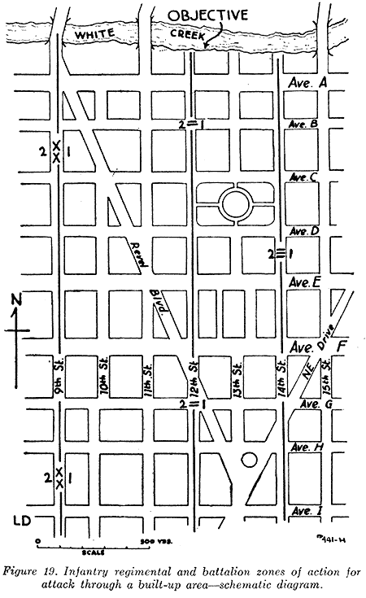
c. Maintenance of direction and determination of the location of units is usually facilitated by the geometric lay-out of the occupied area.
d. If the operation entails a considerable advance, the regiment will usually be disposed initially in column of battalions.
e. A large portion of supporting weapons will ordinarily be attached to battalions. The determining factor in the decision will be whether control and close support can best be obtained by such attachment. Steps must be taken to insure that the attached weapons are provided with close-in infantry protection.
f. Reserves will ordinarily have little opportunity to maneuver within the regimental zone of action. Their primary missions will be to repel counterattacks and to mop up hostile resistance which has been bypassed by forward elements. They may also be used to maneuver through the zone of an adjacent unit which has advanced more rapidly, for the purpose of striking in flank resistance which is holding up the attack of the regiment. A portion of the heavy weapons of reserve battalion (s) initially may be assigned close support missions with the forward units. The heavy machine guns of the reserve may be assigned antiaircraft missions; when assigned such missions, they must revert to control of their own battalions when those units are committed to action.
g. During the advance through the built-up area, attached engineers may be used for any or all of the following purposes:
(1) To clear areas of antitank and antipersonnel mines and booby traps.
(2) To clear lines of communication, including the removal of street barriers and the temporary repair of streets.
(3) To execute demolitions.
h. Certain conditions will require the use of special equipment or personnel or both. Rifle squads may be especially equipped and employed as assault squads for reducing strong fortifications. The size, composition, and equipment varies with the nature of the task. (See chs. 5, 6, and 7, pt. one.)
i. Available tanks are kept in reserve for the performance of suitable missions, including meeting hostile counterattacks. Individual tanks and tank destroyers may be used as accompanying guns to attack by fire strongly fortified buildings and to assist in reducing barricades. Tanks so used must have close infantry support. The use of long-range flame throwers installed in tanks will be effective in neutralizing enemy resistance and possibly in driving the enemy from cover.
j. Supporting artillery will rely to a large extent upon forward observers for the adjustment and observation of fire. At times, leading infantry elements that are without cover may have to withdraw a short distance so that they will not be endangered by concentrations fired in close support. The characteristics of the light howitzer afford great flexibility of the trajectory to include high-angle fire.
k. Chemical combat troops may be attached to an infantry regiment to fire HE concentrations and smoke missions to blind observation, cover an advance, and produce deception. These units should be employed well forward.
l. The infantry regimental commander must take special steps to maintain communication with subordinate adjacent units. Although the commander will usually be close in rear of the attacking units, he must rely to a considerable extent on liaison officers to keep him informed and maintain lateral communication. These liaison officers will be fairly close to their own units as far as actual distance goes, but may have difficulty in communicating due to dead spaces in radio and severed wire lines. They must therefore be accompanied by a sufficient number of messengers to transmit their reports and information.
m. Limitations on the extent of demolitions allowed attackers will frequently be prescribed by higher headquarters. This information, together with any additional instructions which the infantry regimental commander wishes to add, must be transmitted by him to the lowest units.
SECTION III
INFANTRY BATTALION
79. PLAN OF ATTACK, a. Formation. (1) The formation to be adopted and zones of advance of companies in the attack are determined by-
(a) Strength of enemy resistance expected.
(b) Width of the battalion zone.
(c) Density and size of buildings within the zone.
(d) Depth of advance required.
(2) When the width of the battalion zone exceeds two blocks, two rifle companies are usually assigned to the attacking echelon. (See fig. 19.) Normally a rifle company is not assigned more than two blocks.
(3) When the built-up area consists of blocks of buildings, such as the business sections of cities or towns, where the buildings must be attacked block-by-block, streets are usually designated as boundaries. The buildings are the immediate objectives and their capture must be made the responsibility of a single commander. (See fig. 20.)
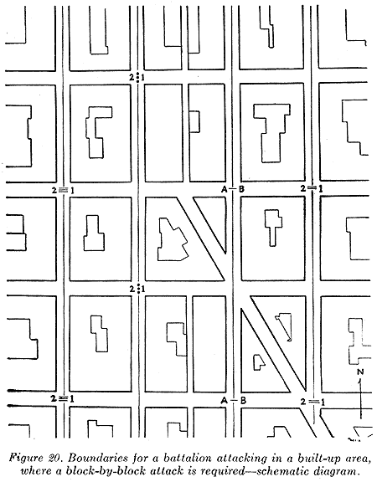
(4) In built-up areas, where the density rf buildings does not require a block-by-block attack, it may be desirable to designate boundaries within the blocks in order that houses on both sides of streets will be included in the zone of one attacking unit. (See fig. 21.)
b. Objectives. Successive objectives are assigned attacking rifle companies, with plans made to continue the attack from each. Suitable objectives are streets, rivers, and railroads crossing the line of advance. Reports are required from companies as each objective is reached, and reports are made to regiment when the battalion objective is reached.
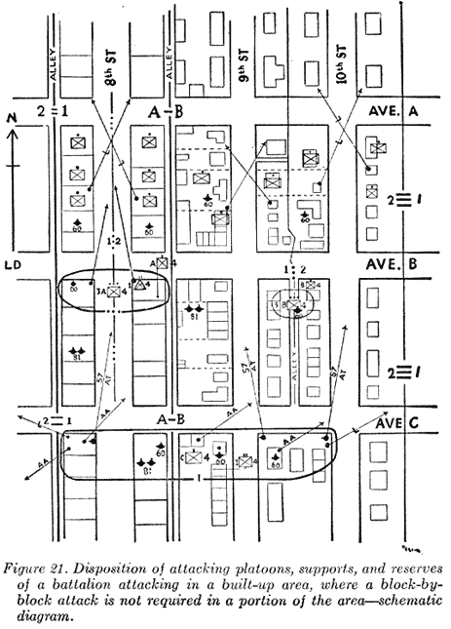
80. EMPLOYMENT OF SUPPORTING UNITS, a. Antitank and cannon weapons. Available antitank weapons are emplaced to cover streets from which mechanized counterattack appears probable. Some or all of the battalion antitank guns may be attached to leading rifle companies for direct-fire missions against fortified positions or buildings in addition to antitank missions. One or more platoons of the antitank company may be attached to battalions. One or more cannon platoons likewise may be attached.
b. Ammunition and pioneer platoon. The battalion ammunition and pioneer platoon assists in getting ammunition forward, in clearing areas of mines and booby traps, and may furnish men specially trained in demolitions to be attached to attacking rifle companies.
c. Heavy weapons company. Usually a large part of the weapons of the heavy weapons company are attached to attacking rifle companies. Normally the battalion commander retains one platoon of heavy machine guns and one section of 81-mm mortars for use with the reserve. These machine guns are usually emplaced initially on roofs for antiaircraft and long-range fire missions. The mortars may be employed initially for long-range fire missions.
81. BATTALION RESERVE. The battalion reserve is kept well forward, usually being from one to three blocks in rear of the assaulting companies. Its normal missions will be to protect the flanks, to repel counterattacks, to move into the zone of an adjacent unit either to assist that unit or envelop the flank of hostile resistance holding up the advance of the battalion, to mop up or consolidate captured areas, and to relieve attacking units by a passage of lines.
SECTION IV
RIFLE COMPANY
82. PLANS. In attacking through a built-up area, the formation adopted by the rifle company will depend upon the number of blocks in its zone of action, the density and size of buildings, the strength of resistance expected the depth of advance required. (See fig. 20.) The mission assigned each attacking platoon is to gain it’s objective, clearing all houses in its assigned zone of advance. The initial objective for the platoon(s) may be the initial company objective assigned by the battalion order, or, when strong resistance is expected, one or more intermediate objectives may be assigned. Subsequent platoon objectives may be the successive cross streets, depending upon the nature of the anticipated resistance. Platoons will be required to report promptly their arrival at each objective.
83. SUPPORTING UNITS AND SPECIAL EQUIPMENT. a. When two platoons are attacking abreast and heavy machine guns are attached to the company, the company commander will normally attach them to one of the attacking platoons, and the light machine-gun section to the other platoon. When no heavy machine guns are attached to the company, one light machine-gun squad may be attached to each of the attacking platoons. Machine guns not attached to platoons are usually retained under company control to support the attack and be prepared for attachment to the support when it is committed. The 60-mm mortars are usually attached to platoons. Other weapons attached to the company are usually retained initially under company control.
b. The support platoon is held close behind attacking platoons to mop up bypassed enemy elements, or to pass through a depleted or disorganized platoon.
c. When the company has been reinforced with special equipment such as explosives and flamethrowers, such equipment is allotted to the assault platoons.
SECTION V
RIFLE PLATOON
84. PLAN OF ATTACK, a. Objective. A rifle platoon in the attack of a strongly defended built-up area is ordinarily assigned not more than one block. (See fig. 20.) It may be assigned a cross street, exclusive, as its initial objective and directed to be prepared to continue the attack on order. It immediately reports its arrival on the objective.
b. Formations. Suitable formations for a platoon attacking through a built-up area are shown in figures 21 and 30.
85. CONDUCT OF ATTACK, a. The advance. The block-by-block attack of a rifle platoon requires alert, aggressive leadership on the part of the platoon leader. After the attack has been launched (see par. 81 and fig. 30), he maintains close contact with his leading squads and promptly supplies covering fire and support as needed. When he observes that smoke or additional supporting fire will facilitate the advance, particularly across parks and open areas, he calls for it promptly. When the platoon must attack on both sides of a street, the platoon leader uses his platoon sergeant or platoon guide to conduct the advance on the side where least resistance is expected, while he takes the other side. When an attacking squad is held up, the support squad is used promptly to maintain the impetus of the attack. When an objective is captured, the platoon leader notifies the company commander, promptly reorganizes his platoon if necessary, and prepares to resume the attack
b. Supporting arms. If machine guns are attached to the platoon, they may be used initially to cover the entry of attacking squads into the first buildings of the block being cleared and to cover the streets and alleys. Thereafter, they are displaced by the platoon leader as the situation dictates. Attached 60-mm mortars are weapons of opportunity, and they and their observers must be well forward near leading attacking squads. Their shells will have little effect against solidly constructed buildings or troops with overhead cover. They will have their principal use against enemy snipers on roofs and troops behind barricades or other shelters without overhead cover. The 81-mm mortar, using the heavy shell will wreck lightly constructed buildings and penetrate most roofs. Smoke shell, when required, is used to cover the advance, particularly across open spaces. WP shells may be employed for their incendiary effect.
c. Reinforcements. (1) The platoon will frequently be equipped with explosives, rocket launchers, and flame throwers These are used to equip assault squads.
(2) Strong buildings and emplacements stubbornly defended may be reduced or neutralized by direct-fire assault guns (either organic infantry cannon or attached artillery pieces), or armored vehicles brought forward under company or battalion control. The platoon must protect these weapons by fire, and assault the objective the instant the fire lifts. Close coordination is required.
d. Barricades. It may be necessary to overcome enemy resistance at a barricade that cannot be outflanked. Here the 60-mm mortars may be effective. When a frontal attack becomes necessary, the enemy should be blinded with smoke. It may be well to wait for the second or third cloud before assaulting the barricade. If constructed of inflammable material, the barricade should be reduced by incendiary action.
SECTION VI
RIFLE SQUAD AND INDIVIDUAL
86. TRAINING. Combat in built-up areas requires thorough individual and small-unit training and the exercise of the highest degree of initiative, skill, cunning, and courage on the part of the small-unit leaders and individual soldiers. No two situations are alike.
87. METHODS OF ADVANCE. The advance will be from house-to-house through side yards; over rooftops; by breaching walls; or through back yards, streets, or alleys. the zone of advance of an attacking squad normally includes one side of the street only. Leading troops avoid streets as much as possible, as they are usually well covered by enemy fire. When required to advance along a street, the advance is made in two or more parties, each covering the opposite side of the street. If possible, the advance should be covered by a machine gun advantageously located. The squad is given a mission of clearing a particular house with instructions that as soon as the house is cleared, it will cover the advance of an adjacent squad, or proceed to the next house, or both. All movements across open spaces must be covered by fire and made at a run; the movement should be screened by smoke or other means, if practicable.
88. EQUIPMENT, a. Individual. Troops engaged in house-to-house fighting should be lightly equipped. Steel helmets, rifles, bayonets, and hand grenades are essential items. Special equipment, such as rubber- or rope-soled shoes, submachine guns, pistols, knives, toggle ropes, and grappling hooks are frequently useful. An extra pair of socks pulled over the shoes, or burlap strips wrapped around the shoes, may be used in lieu of rubber-soled shoes. Each squad or detachment should have heavy tools, such as crowbars and axes, for use in breaking through doors, walls, and roofs.
b. Special. A rifle squad will frequently have available men equipped with explosives, rocket launchers, and flamethrowers. Squad leaders are trained how to use these weapons effectively in the house-to-house advance.
89. CONDUCT OF ATTACK. The following principles, methods, and procedures should guide squad leaders and individuals in the advance and attack:
a. Since house-to-house fighting is difficult to plan in advance and depends upon the teamwork of individuals and small units, details of execution are decentralized to subordinate leaders. The immediate mission and plan of each group must be clear and unmistakable, and thoroughly understood by each individual.
b. Subdivision of the squad into two or more groupings comprising covering and searching parties, is frequently necessary.
(1) The covering party must protect and facilitate the advance of the searching party toward the building under attack by covering by fire the movement of the searching
(2) It is the duty of the searching party to enter and search all buildings which may be held by the enemy. The searching party must be kept small because too many men get in each other's way when fighting in close quarters One or two of the searching party, properly equipped and adequately covered by fire, precede the party and force entry into the building. The remainder of the searching party follow promptly. Once inside the building one or more men are posted to prevent surprise. The remainder of the group go about the task of clearing the building in accordance with a prearranged plan. As a general rule, the minimum number of men are assigned to each task.
c. The city, town, or village must be systematically attacked, section by section. Adherence to this principle will reduce the possibility of leaving hostile centers of resistance in the rear.
d. The line of advance chosen must be one which does not mask the covering fire. It should also be remembered that it is suicidal to delay in the open.
e. Streets, alleys, vacant lots, and open areas afford the best fields of fire for the defender and therefore constitute areas to be avoided or crossed with caution. .
f. Cover must be selected in advance. It is too late to select cover when being fired upon. Hug walls and move rapidly from cover to cover. Quickly roll over roof tops and walls. Do not go over them upright. (See fig. 22.) The individual must be trained to fire around the right-hand side of cover from the right shoulder and around the left-hand side from the left shoulder, as he exposes less of the body in that way. (See fig. 23.) He avoids, if possible, firing over the top of cover unless the firer's silhouette will blend with his background.
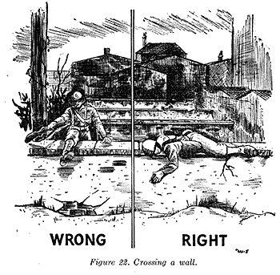
g. In combat, more unnecessary casualties result from bunching than from any other cause. This is especially true in house-to-house fighting. (See fig. 24.)
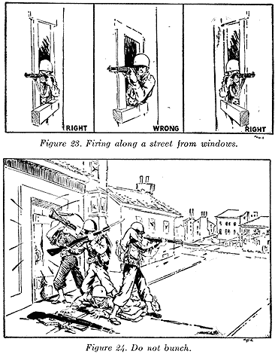
h. Control will be difficult when the fighting occurs among buildings. Movement in close proximity to the enemy must be planned in advance, executed rapidly, and always covered by fire. It is extremely important that there be preliminary planning for maintaining coordination during the attack.
i. There must be close coordination with supporting weapons. Automatic supporting weapons will be placing heavy fire down streets and open areas. If rifle units must cross these streets or open areas in their advance, these fires must be lifted according to previously planned signals.
j. House-to-house fighting lends itself to surprise situations. The object is not only to avoid being surprised but to surprise and annihilate the enemy. Every effort is made to create and take advantage of diversions which temporarily distract the enemy's attention; for example, the use of hand smoke grenades in areas in which it is not intended to attack.
k. There are three methods of entering and clearing a house:
(1) Through the roof, upper story windows, or upper story walls; working down to the ground floor or cellar; and clearing each floor systematically.
(2) Entry by means of a hole in the wall at ground level made by explosives.
(3) Entry effected through ground floor doors or windows.
l. Entrance through the upper part of a building is better if it is possible, because it is much easier to work down than up. (See fig. 25.) Also, when the enemy is forced down to the ground level he may be tempted to withdraw from the building and expose himself to the fire covering units or machine guns. The cornered enemy will fight desperately, and therefore it is advisable to make it seem that there is an avenue of retreat open. At the same time, somewhere along this apparent avenue of retreat the attacker's fire should destroy him
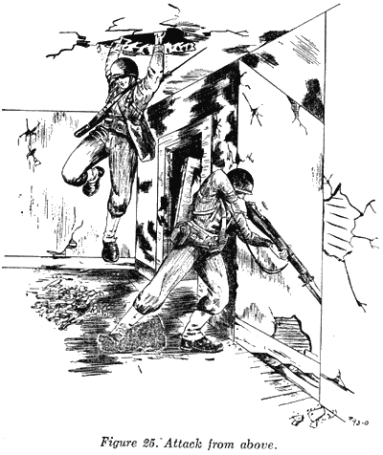
m. Various means may be used to reach the top floor or roof of a building. Ladders, down-spouting, vines, or the roofs of adjoining buildings may be used. In many instances soldiers can climb onto the shoulders of their comrades and reach high enough to pull themselves up. If available, toggle ropes are extremely useful, these are short ropes from 4 to 6 feet long with an eye at one end and a short stick at the other See fig. 26 ) Several toggle ropes can be joined together to form wall-scaling ropes. By attaching ropes to a grappling hook, an individual can scale a wall (see fig. 27), swing from one building to another, or use it to gain entrance to an upstairs window.
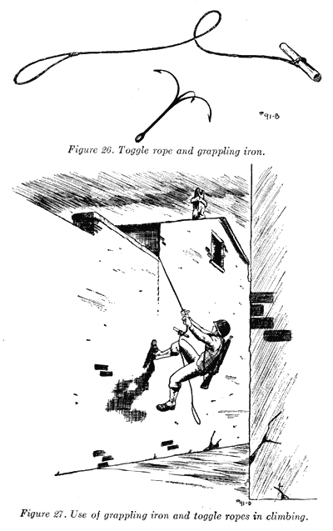
n. After clearing the rooms of an upper floor, a grenade may be thrown down before descending. One man follows it quickly, covered by his partner. Sometimes it will be impossible to use the staircase. In such cases, a hole chopped through the floor will do A grenade dropped through this hole before descending may be effective Another method of causing confusion among the enemy below is to place two or three grenades on the floor, pull the pins, and quickly cover them with a mattress so that the force of their explosion is directed downward. If this accomplishes nothing else it usually will dislodge the ceiling plaster of the room below, thus filling the room with dust, confusing the enemy, and handicapping his observation.
o. Sometimes it will be impossible to enter buildings from the top. In such situations, the men must be trained to enter rapidly and to get upstairs as quickly as possible If the stairway is barricaded and it is impossible to get upstairs rapidly, clear the rooms on the lower floor first When the lower floor is clear, take steps to remove barricade on stairway as quickly as possible. Fire up through the ceilings systematically so as to create confusion and disorganization in rooms above while the barricade is being removed. Modern military rifle bullets will penetrate most floors, ceilings, and interior walls. Guard against similar fire from the enemy. (See fig. 28.) Experience has shown that this expedient is not always effective, and may result in considerable waste of ammunition. It should be used only in emergency situations such as the one described above.
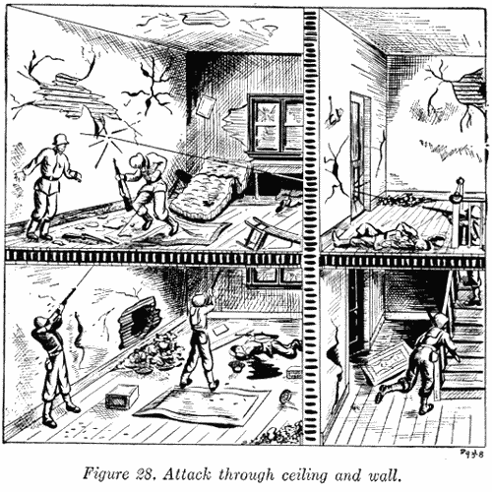
p. If there is reason to believe that an armed enemy occupies a room, it is suicidal to rush into that room without first killing or disabling him. It is much safer to breach a small opening and toss a grenade inside. In entering a room believed to be occupied by the enemy, the attackers must work in pairs, using the "buddy" system, with each man alternately covering his buddy's movements. In this system, one man throws the grenade into the room. The other rushes in immediately after the explosion, stands with his back to the wall and his rifle ready for instantaneous use, and covers his partner as he searches the room for occupants. In entering rooms through doorways, riflemen should crouch as low as possible and jump to one side of the door. The defender usually will have his point of aim at approximately waist height. In breaching a wall, take precautions for protection from enemy fire through the wall and keep the hole covered by fire to prevent him from throwing the first grenade. Before throwing grenades at windows or doorways, look to see that they are not covered. Do not assume that a grenade bursting in a room has disabled all of the enemy. In a defended room, the enemy may erect a barricade in a corner as protection from grenades. Watch out for such a barricade and have another grenade ready to throw behind it. (See fig. 29.)
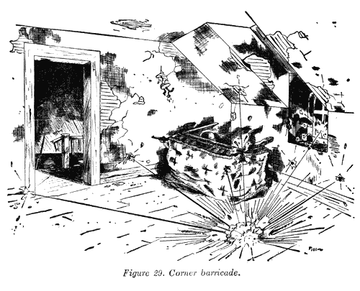
q. Search every house from attic to cellar as the advance is made. It is fatal to leave a house in your rear occupied by the enemy. In conducting this search, look for holes in the wall made to afford the enemy rapid ingress or egress. These holes will frequently be found in concealed locations, such as behind furniture, under stairways, or in cellars.
r. Make provision for a simple means of identifying buildings which have been cleared by friendly troops. The use of chalk marks constitutes an effective means.
s. If the enemy has strongly defended a building, it is less likely that booby traps will be found in it. However, precautions must never be omitted in examining defended and undefended buildings for booby traps. Electrically operated systems of booby traps make it possible for defenders to operate in the same building with less danger of detonating the charges themselves. In this type, a master switch thrown by the last defender to withdraw from the building can make the entire system effective. Other types are also used in defended buildings.
SECTION VII
ILLUSTRATIVE PROBLEM
90. RIFLE SQUAD IN ATTACK, a. Situation. (1) The first platoon, Company A, with the light machine-gun section attached, has arrived at Main Street and 2d Avenue (see fig. 30) with the mission of capturing the houses on both sides of Main Street between 2d and 3d Avenues. The built-up area consists of a double row of two-story brick dwelling houses with gable roofs. The back yards of these houses are inclosed by a brick wall 8 feet high. Other platoons are advancing on adjacent streets.
(2) Platoon leader's order-
"We will clear the enemy out of the houses on both sides of Main Street between 2d Avenue (pointing) and the next avenue to the north.
"Light machine-gun section cover Main Street from corner buildings A and B.
"1st Squad clear houses on right of street; cover right alley.
"2d Squad clear houses on left of street; cover left alley.
"3d Squad in support with one-half at building A and one-half at building B. Cover initial advance of 1st and 2d squads, protect machine guns, and cover rear. Automatic rifle of 3d Squad will take roof top position on building B and cover roofs of houses along Main Street. Be prepared to advance on my order.
"1st and 2d Squads will cover each other's movements as they work through their respective sides of Main Street.
"The signal for designating that a building has been cleared will be a small strip of white cloth hung from the upstairs window. On this signal the squad on the opposite side of the street will continue its progress to next house.
"Move out at 0943. It is now 0931
"I will be at A.
"Any questions?"
b. Standing operating procedure. A standing operating procedure (SOP) for the rifle squad in the attack of a building is developed as the result of training in this type of operation. This training will normally be intensified when the imminence of such an operation becomes apparent. For the attack and clearance of buildings, such as presented in this illustrative problem, a standing operating procedure should cover the following:
(1) Composition of searching party: squad leader with four to six riflemen.
(2) Composition of covering party: second-in-command with remainder of squad.
(3) Action of searching party: enter building rapidly, work in pairs and clear interior, room by room and floor by floor.
(4) Action of covering party: covers advance of searching party into building from suitable positions; upon signal, reinforces searching party.
(5) Action of squad after building is cleared: searching party prepares to attack next building; covering party takes new position to cover searching party and adjacent squads.
c. Requirement. The order of squad leader, 1st Squad.
d. A Solution. Squad leader's orders (1st Squad)-
"You know the situation.
"3d Squad and light machine-gun section will cover us.
"We will clear houses on right of Main Street and support 2d Squad on left side of street.
"Searching party: Nos. 2, 3, 4 and 5.
"Covering party: remainder of squad.
"Nos. 2 and 3 will force entrance into that building (pointing). Signal when clear. I will follow. Nos. 4 and 5 follow me.
"Covering party have AR team cover alley (pointing) and keep abreast of our advance. Others cover us from here until signaled forward.
"Any questions?
"Get ready. We move in 5 minutes, on my order."
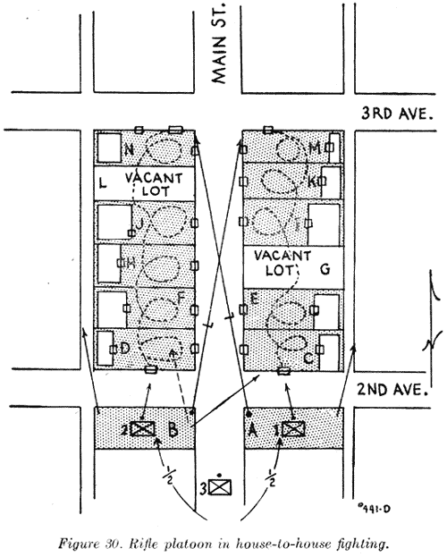
CHAPTER 3
THE DEFENSE
SECTION I
GENERAL
91. MILITARY VALUE OF BUILT-UP. AREAS. Cities, towns, and villages constructed of inflammable materials afford little protection. Those of masonry construction can be developed into well-fortified, tankproof islands of resistance which offer opportunities for a strong defense. The advantages are on the side of the defender. Each building and each block is a potential fort which provides such concealment that the attacker is unable to tell which is strongly defended and which is lightly held, causing him to disperse his fires and waste his ammunition. The attacker's bombardment serves to increase the camouflage of the defensive position by creating rubble and debris. Adequate underground cover is available or can be prepared so that the defender may take shelter during heavy bombardments and emerge promptly to meet the enemy assault. As the enemy infantry approaches the position, his artillery fires must lift and his bombers shift to other targets.
92. DEFENSIVE POSITION, a. The defense of a built-up area is comparable to the defense of any battle position in that the plan of defense must insure covering the front and flanks by fire, and provide depth, mutual support, all around protection, and adequate weapon support. The built-up area to be defended must be so situated in relation to the general defensive dispositions as to force the enemy to a direct attack or a time-consuming maneuver. A position that can be readily avoided has little defensive value.
b. The main line of resistance may be either inside or outside the built-up area, but is never along a clearly defined edge. The near edge of a built-up area is a convenient registration point for artillery and is likely to be subjected to the most concentrated fire. In the usual situation, the main line of resistance may be advantageously located in suburban districts so as to command avenues of hostile approach and take full advantage of observation, fields of fire, and opportunities for flanking fire against attacking forces. The holding garrisons consist of a series of unit defense areas with supporting weapons attached, each occupying a separate tactical locality (one or more buildings or blocks of buildings) permitting small-unit control. These defense areas are distributed laterally and in depth in such manner that the fires of each cross the front or flanks of adjacent elements. Boundaries are usually located in streets and limiting points at street intersections, as these features provide unmistakable locations and facilitate mutual coordination between adjacent units.
c. All approaches must be prepared to resist the initial attack by the use of defended road blocks, barricades, mines, pill boxes, and barbed wire, with small defense areas at all advantageous locations.
d. The number and kind of obstacles that may be used are limited only by the time, materials, equipment, and labor available, and the ingenuity of the defender. However, obstacles may interfere with maneuver, supply, and evacuation of friendly troops, and may disclose details of the position to the enemy. The type and priority of construction of obstacles is usually ordered by higher authority. Tank barriers may be improvised by blowing large craters, demolishing walls, overturning or derailing street or railway cars, and by the use of steel rails, beams, and rubble obtained from demolished buildings. Such barriers should be reinforced with antitank mines and protected by wire, antipersonnel mines, and by small-arms and antitank fire, including antitank guns, rockets, and incendiaries, from locations in nearby buildings. Such barriers will serve the dual purpose of furnishing protection from mechanized attack and attack by foot elements.
93. CIVILIAN CONTROL. Defense of a built-up area necessitates timely and effective disposition of all persons unwilling or unable to contribute to the defensive effort. It also necessitates the control of essential utilities. Where practicable, friendly inhabitants should be regimented into the defensive force, because such individuals usually have the will to resist and, if placed in a good position, can stop forces of superior military training, particularly when fighting for their own homes. Brassards or other forms of identification must be provided.
94. SUPPLY. All types of supplies should be dispersed and stocked sufficiently to sustain each tactical locality, however small, for a prolonged period in case the locality becomes isolated. Ammunition, food, water, and other critical items must be securely stored in bomb, fire, and gasproof shelters. The supply and distribution of water for personnel and fire fighting may become a major problem because of contamination or destruction of local sources of water supply. Supply plans should include plans for replenishment by aircraft and hand-carrying parties. Activities pertaining to supply and evacuation usually will be carried on at night.
SECTION II
INFANTRY REGIMENT AND ITS
SUPPORTING ARMS
95. DISTRIBUTION OF TROOPS. An infantry regiment assigned to the defense of a battle position distributes its elements in three echelons: security forces, holding garrisons, and a reserve. It usually assigns two battalions to the defense of the main line of resistance and one battalion in the reserve. (See fig. 31.) The reserve battalion may be assigned an initial mission of security. The regimental commander assigns defense areas to the battalions by designating boundaries and limiting points. Elements of the antitank company and of the cannon company may be attached to battalions.
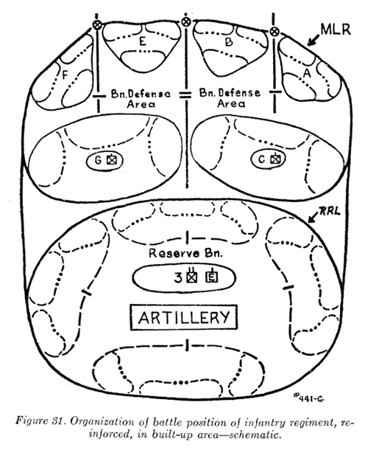
96. EMPLOYMENT OF SUPPORTING UNITS, a. Artillery. The artillery is disposed to support the outpost and mass its fires on likely avenues of hostile approach. It is usually held under centralized fire control and successively executes the following fire missions as the attack develops: the counterpreparation; fires to break up the attack after it is launched and prior to reaching the defensive positions along the perimeter of the town; barrages for the final defense of the perimeter. During the above periods the commander may decide to emplace a portion of his artillery in the vicinity of the perimeter to assist by direct laying in the final defense against the hostile attack. This command decision must state whether or not these guns are to remain in place and be sacrificed or whether they are to withdraw under certain conditions. When adequately protected, the artillery is preferably disposed in rear of and beyond the limits of the town, generally in a central location, echeloned in depth, and so emplaced that the bulk of its fires may be massed on the critical avenues of approach and during the final defensive fires. In the event that the enemy is successful in penetrating the town, the bulk of the artillery must still be able to mass its fires against these penetrations and to support counterattacks by the defending troops. In addition, part of the artillery must be so emplaced that its fire power can be employed against envelopment of the town or against hostile forces within range that are attempting to bypass *the town.
b. Antitank mine platoon. The antitank mine platoon will be employed to improve natural obstacles, construct artificial obstacles and road blocks, and lay mines. It usually will be kept under regimental control, operating under the regimental antitank officer. When engineer troops are attached to the regiment c below, the employment of the antitank mine platoon should be coordinated with the engineers.
c. Engineers. Attached engineer troops are employed in the execution of engineer work such as the maintenance of routes; construction of pill boxes, obstacles, and bombproof cellars and dugouts; the execution of demolition and mining operations; and the installation of booby traps and antipersonnel mines. The types of obstacles to be constructed and the priority of construction will be prescribed by the infantry regimental commander. He may charge the engineer officer with the preparation of plans for and the construction of obstacles and the execution of demolitions, or he may decentralize this function to battalion commanders, attaching engineer troops to assist in this work. Engineer troops can be made available as a final reserve for infantry combat. (See fig. 31.)
d. Communication. Organic means of signal communication should be supplemented by the use of local wires, cables, and conduits, particularly those located under ground. Several independent wire lines should be laid to connect regimental, battalion, and supporting unit command posts. Wire lines are laid underground if possible.
e. Intelligence and reconnaissance platoon. The bulk of the intelligence and reconnaissance platoon is employed initially with the security forces. After the security forces have been driven in, elements of the platoon may be used to observe for enemy operations on the flanks and in rear and for patrolling.
f. Chemical units. Chemical combat troops attached to an infantry regiment may be employed to fire HE concentrations or for smoke missions.
g. Tanks. Tank units available may be employed as a mobile reserve for counterattack.
97. RESERVES. Regimental and battalion reserves are primarily intended for use to prevent encirclement, to counterattack penetrating elements, and to defend the flanks and rear. They may be held mobile in bombproof shelters or used to occupy previously prepared positions.
SECTION III
INFANTRY BATTALION
98. FRONT LINE BATTALION, a. A battalion occupying a defense area on the main line of resistance in a built-up area will usually be assigned a frontage of four to eight city blocks, depending on'the defensive strength of the locality. The depth of the defense area may vary from three to six city blocks. The battalion is responsible for the all around defense of its assigned area, and all installations of the battalion are contained therein. For illustration of a typical battalion defense area, see figure 32.
b. The battalion commander usually places two rifle companies on the main line of resistance and holds one in reserve. All or part of the crew-served weapons, including attached cannon company, antitank and chemical weapons, may be attached to rifle companies. As soon as possible, obstacles are constructed, supplies are brought up, and the area is fully organized for defense. Small holding detachments are provided by the reserve company for its defense areas.
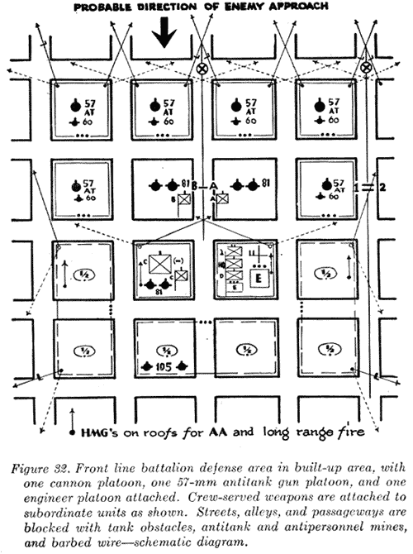
99. .RESERVE BATTALION. The reserve battalion usually organizes its position in the rear portion of the regimental area so as to complete the all around defense of the regimental sector. After completing the organization of its assigned defense areas, the battalion (less small holding garrisons left in each defense area) usually is assembled in bombproof shelters prepared to counterattack any penetration of the regimental sector or to occupy its previously prepared positions. Elements of the reserve battalion may be employed initially on security missions or, in certain situations, held in readiness outside the built-up area to prevent encirclement.
100. EMPLOYMENT OF SUPPORTING UNITS, a. Battalion headquarters company. Battalion intelligence personnel will establish a system of protected observation posts from which the front and flanks of the battalion area may be observed. Advantage should be taken of high buildings for this purpose. The probable effect of enemy shelling and bombing, and limitation of visibility by smoke, must be kept in mind and a number of alternate observation posts prepared. The battalion communication system should be established so as to make the maximum use of the sound-powered telephone and visual signaling equipment available. Wires are laid through cellars or placed underground. Attempts to jam the radio system may limit or prevent the effective use of the battalion radio equipment. All men available for use as messengers must be familiar with the battalion area and protected routes to and from the regimental command post. Elements of the antitank platoon usually are attached to front line companies. Personnel of the ammunition and pioneer platoon not required for ammunition supply may be assigned elementary engineering tasks or grouped with attached engineers.
b. Engineers. Engineer troops, if attached, are employed to construct or remove obstacles and other works requiring special equipment and specialized training, such as barricades, and pill boxes, and to execute demolitions and install booby traps. They may be grouped with the ammunition and pioneer platoon of the battalion headquarters company. They are also available as a reserve for combat.
SECTION IV
RIFLE COMPANY
101. DISTRIBUTION OF RIFLE COMPANIES, a. Front line companies. (1) Usually two rifle platoons are assigned defense areas on the main line of resistance and one rifle platoon in the company support area. (See fig. 32.) Platoon defense areas are located so as to be mutually supporting and capable of all around defense. Available 57-mm antitank guns, machine guns, and 60-mm mortars are usually attached to rifle platoons. If other crew-served weapons, such as 105-mm howitzers, 81mm mortars, and 4.2-inch chemical mortars are attached to front line companies, they are usually held under company control.
(2) A rifle company occupying a defense area on the main line of resistance in a built-up area usually will be assigned a frontage of two to four city blocks, depending on the defensive strength of the locality. The depth of the company area may vary from two to three city blocks.
(3) Each front line company should decentralize its supply plans by distributing ample quantities of all critical items to each defense area.
b. Reserve company. The reserve rifle company usually organizes its position in the battalion rear area so as to complete the defense of the battalion area, and protects the flanks and rear. (See fig. 32.) After completing the organization of assigned defense areas, the company (less small holding garrisons left in each defense area (see fig. 32)) is assembled in bombproof shelters prepared to counterattack any penetration of the battalion area or to occupy its previously prepared positions. Elements of the reserve company may be employed on security missions.
SECTION V
RIFLE PLATOON
102. TACTICAL EMPLOYMENT, a. Defense area. In the defense of a built-up area, a rifle platoon, with crew-served weapons attached, may be employed to organize and defend a tactical locality on the main line of resistance, in the company support area, or in the battalion reserve area. It normally occupies one defense area. For an illustration of a typical rifle platoon defense area and a method of occupation thereof, see figure 33.
b. Organization of platoon area. (1) A rifle platoon defending a tactical locality assigns each rifle squad to a clearly defined area of responsibility. The platoon area is systematically organized into a fortified position for all around defense by skillfully emplacing the attached crew-served-weapons, improving local fields of fire, constructing obstacles to both mechanized attack and attack by enemy foot troops, preparing bomb and gasproof shelters, storing ample quantities of ammunition, food, water, medical supplies, and equipment for a prolonged defense, and establishing a reliable system of communication with adjacent and higher units. Having organized the defense, the available personnel is then divided into two reliefs, with one relief constantly on duty while the other relief is resting. During an alert the position is fully manned.
(2) Sentries should be posted outside a building whenever possible, especially at night. They should be on ground level, and on the roof if the latter is accessible to the enemy. From the outside they will be in a better position to listen for and investigate any movement.
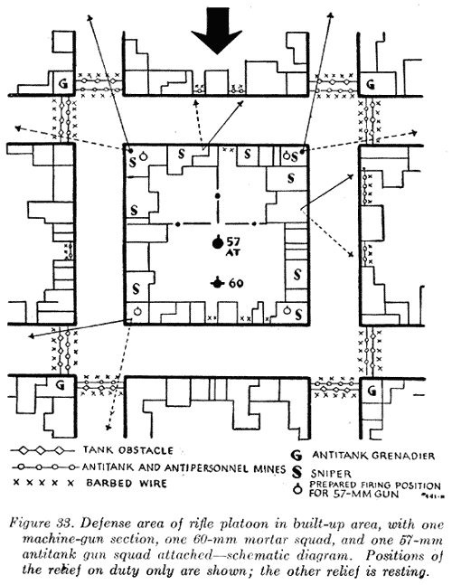
103. DEFENSE OF BUILDINGS. In preparing buildings for defense, the first consideration is the selection of buildings of solid construction suitably located for the accomplishment of the tactical mission. Buildings which are so located or so inflammable as to weaken the defensive position may be demolished or burned, if such action will not unduly disclose to the enemy the details of the position. If extensive demolition is required, the approval of higher authority should first be obtained. The next step is the organization of each selected building for all around defense by the disposition of squads and individuals; the assignment of principal, alternate, and supplementary positions to attached crew-served weapons; improvement of fields of fire by the removal of fences, hedges, and outbuildings that obstruct the view; and by the construction of obstacles. Machine guns assigned to close-defense missions are emplaced on or near the ground level so as to command the avenues of approach; those given antiaircraft or long-range fire missions are usually located on the roof. Antipersonnel mines and booby traps (see FM 5-30) should be installed in buildings which are not occupied or from which the defenders are withdrawing.
SECTION VI
RIFLE SQUAD AND INDIVIDUAL
104. ORGANIZATION OF A FORWARD SQUAD DEFENSE AREA. a. General. The platoon leader's defense order assigns to the rifle squad the building or buildings to be occupied and defended, the obstacles to be constructed, specific area of responsibility, and general locations and principal directions of fire for the automatic rifleman and the antitank rifle grenadier. The location and sector of fire of members of the squad and the assignment of individuals to reliefs and duties are functions of the squad leader.
b. Position of squad. During an alert the squad defenses are manned by all available personnel and weapons. At other times the squad is divided into two reliefs with one relief on duty while the other relief is resting, as follows:
First relief Second relief
Sergeant, in charge. Corporal, in charge.
Private, automatic rifleman. Private, automatic rifleman.
Private, AT grenadier* Private, AT grenadier*
Private, rifleman. Private, rifleman.
Private, rifleman. Private, rifleman.
Private, rifleman. Private, rifleman.
* Assigned by squad leader.
105. PRECAUTIONS AND SUGGESTIONS. The methods and expedients indicated below should guide squad leaders and individuals in the preparation of buildings for defense:
a. Every defensive measure should be taken to prevent the enemy from getting above the defender and fighting his way down.
b. Principal, alternate, and supplementary loopholes for riflemen and for all weapons should be prepared, reinforced, and camouflaged. Loopholes may be made high so that the firer can fire from a platform, or low so that he can fire from the prone position. Low loopholes are blocked with sandbags when not in use. It is good practice to fire successive shots from different loopholes, if practicable. Dummy loopholes and dummy heads may be used to draw the enemy's fire. (See fig. 34.)
c. Use great care in the selection of firing positions. Always try to fire from unexpected places. Weapons which are to be fired from windows or large openings should be located well back in the rooms. The area in front of the weapon should be wet to avoid dust and consequent disclosure of position by muzzle blasts. Do not allow the muzzle of a weapon to project from cover. Snipers should make frequent changes of position.
d. Remove or sandbag windowpanes to prevent injury from flying glass. Screen or close openings, including the chimney, to exclude grenades. Place curtains over the upper portion of openings to darken the room and prevent observation by the enemy.
e. Guard against surprise, demolition, and fires. Trip or barbed wires with tin cans on them may give timely warning of enemy approach. The floor over basement dugouts or occupied rooms should be reinforced and fire-proofed with wet earth or masonry. Keep some fire fighting equipment in readiness for instant use. Remove inflammable materials.
f. Prepare one or more well camouflaged and sandbagged observation posts in the attic or upper story. These locations may also be used for sniping or to prevent enemy infiltration over the roof
g. LOOK OUT FOR BOOBY TRAPS, especially if the enemy has previously occupied the building.
h. Always keep one exit available. Breach the walls of interior rooms in concealed places, such as behind heavy furniture, under stairs, or other places not easily discovered by the enemy.
i. Barricade the openings. Doors required for your own use should be bulletproofed by placing sandbags behind them, and the opening restricted to the minimum necessary for passage. The opening should be so located that the enemy cannot see into the room. In some cases it may be necessary to rehang the door to effect this safety precaution.
j. Bulletproof parts of all upper floors, particularly the landings. This can be done with sandbags and will afford protection from enemy fire directed up through the floor
k. Try to keep an empty room between you and the enemy if he is attempting to breach the wall of the building you are in; otherwise you may be killed by the blast. Immediately after the explosion, take position to fire through the hole keeping alert for any hand grenades thrown through the hole.
l. Drop grenades out of windows on an enemy in the street below. A slit in the screen will permit this.
m. Remove down-spouts, or anything by which an enemy may climb the side of the building.
n. Fire through the walls or door if the enemy gains access to an adjoining room; fire through the ceiling, if he is upstairs; fire through the floor, if he is downstairs. (See fig. 28.) The caliber .30 bullet will penetrate most interior walls and floors.
o. Prepare observation holes in the floors and walls and cover them with a sandbag.
p. If you are forced out, retreat toward the upper story, unless you have a safe exit prepared in the cellar. It is easier to throw grenades downstairs from upper landings than to throw them upward. Prepare a means of escape from upstairs rooms.
q. Prepare a barricade in the corner nearest the door, if you are cut off and unable to escape from a room (see fig. 29), and fight.
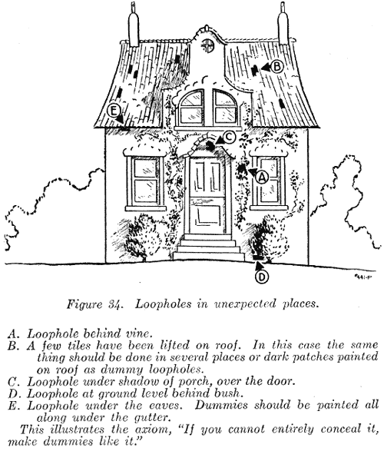
CHAPTER 4
TRAINING
SECTION I
OBJECT
106. GENERAL. Training for fighting in built-up areas must be directed largely to the development by means of demonstration, lecture, and practice of confidence in the use of special methods involved. Each individual must feel not only that he is an expert in such combat, but also that he is certain that the man and subunits alongside him are equally expert and can be depended upon to do their job in the actual fighting, although perhaps out of sight and hearing of himself and of each other.
SECTION II
METHODS
107. TRAINING AREAS. For elementary training a great deal of use can be made of a single house, but at least a small built-up area, including a street, is required for more advanced training, in order to allow those being trained to become accustomed to the feeling of moving in, around, and over buildings for purposes other than those to which they have been accustomed. Normally, realistic training areas can be found within theaters of operations. Built-up areas that have been the scene of recent military operations usually are appropriate for advanced training.
108. LECTURES. Short lectures and training films serve as a useful means of introduction and orientation to demonstrations and for working up interest.
109. DEMONSTRATIONS. These are particularly suitable for this form of training. The area required to stage a demonstration can be small and, yet given good preparation and a sense of showmanship, offers scope for many valuable lessons.
110. MODELS. Built-up areas can be easily portrayed by means of sand table models, dolls' houses, and mock-ups.
111. AERIAL PHOTOGRAPHS. Vertical photographs and vectographs are useful for conducting indoor exercises and for discussions, as they bring out clearly many characteristics of built-up areas.
112. EXERCISES. Whether conducted for individuals or units, the provision of an enemy and battle noises makes for realism. The enemy should be carefully controlled to avoid an undue number of clashes and to simplify umpiring. For small exercises, those not taking part can learn much by acting as observers.
SECTION III
STAGES
113. ELEMENTARY TRAINING. The start of training should be devoted principally to introducing the individual to this particular type of action; to teaching him its characteristics; to increasing his knowledge of items such as types of walls, drains, manhole's, attics, eaves, roofs, shafts, and cellars; to giving him practice in movement both by day and by night; and generally to making him appreciate the combat potentiality of a built-up area.
114. ADVANCED INDIVIDUAL TRAINING. This stage should include the finer points in use of weapons and explosives, the recognition and location of fire, agility, stealthy movement and bold, rapid movement, the selection of positions and use of cover, observation, and the preparation of a house for defense.
115. TEAMWORK. The development of teamwork should include the teaching of group action, and generally the welding of individuals into teams.

