WW2 Era Footlockers

(or for marines, "Lockerboxes". And for the navy, "SEa Chests")
By Brian Mead
Plywood Style 1 | Plywood Style 2 | Crate Style | Officer | M1948
As I've been buying footlockers for storing my reenacting gear, I've started to notice different patterns/styles of WW2 footlockers. (I am not a "footlocker collector", but rather just a reenactor with too much stuff!) Below are photos of the different ones I've got. This is not a complete list of all variants, etc, but rather just what I know.
Thanks, Brian Mead

Plywood Footlocker #1
This seems to be a more heavily reinforced/constructed version of the more common plywood footlocker shown below. Notice the side handles are thinner. It makes it a bear to lift, but creates less wasted space between footlockers when shipping. Also the metal edges & the two additional clasps make the footlocker a much sturdier box when shipping. Also check out the "cool" font for the US and maker's marks. Not what you'd usually see on a government item! My GUESS is that this is an early pattern, which was simplified sometime in 1943 due to war production concerns. This example is owned by Steve Thrasher.
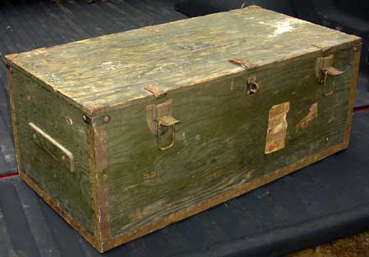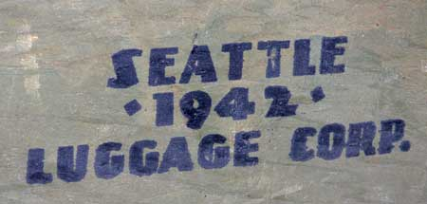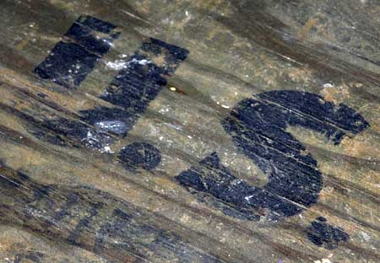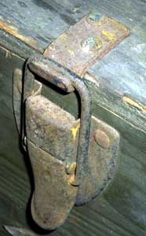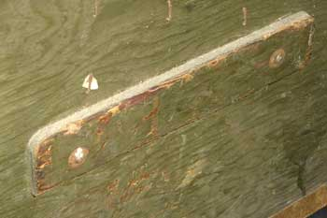
Other Manufacturers:
SANDERSON & SON - 1942 - submitted by Chris Dulaney, 18th Luft

Plywood Footlocker #2
These footlockers are the common footlocker of the US Army. I've seen this same pattern footlocker with 1960's dates.
You'll see that the corners are reinforced with straps of metal, and the side handles are thicker than the example above.
Example 1
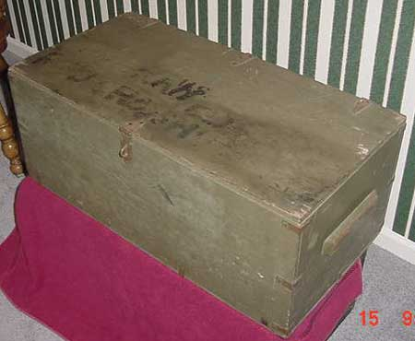
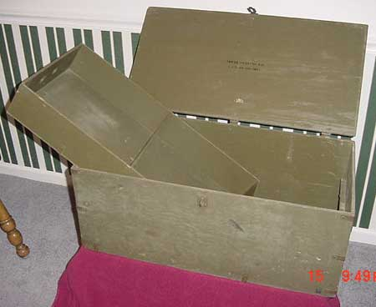
Example 2
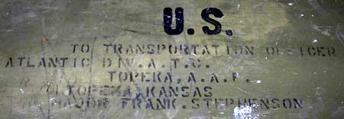
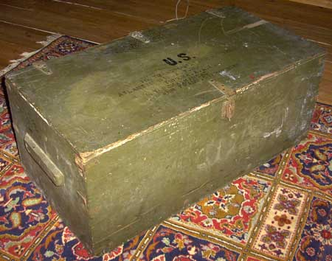
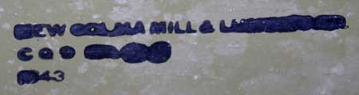
Anyone want to guess on what this one says? =^) I guess the important part is the 1943.
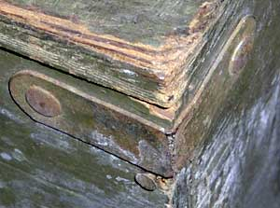

Crate-Style Footlocker
The examples of this footlocker that I've seen have all been dated 1943. This one seems to be the easiest to construct, since it's very similar to the packing crates & ammo crates of the period.
Click here for Construction Drawings!
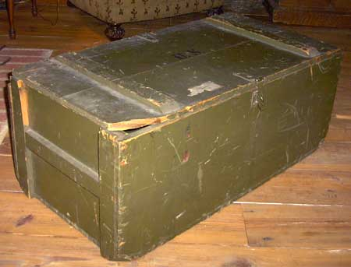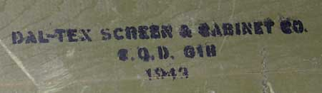
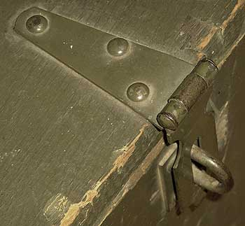  Lock Clasp | 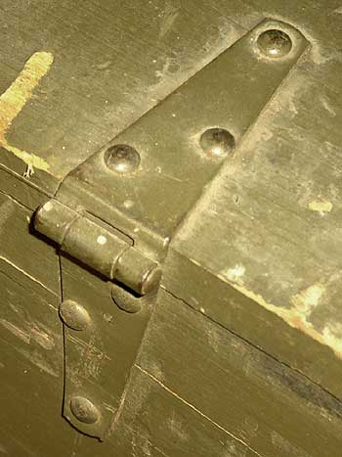  Hinge

"Officer's" Footlocker
Example 1
This example is owned by Steve Thrasher. I'll find out more about it later...
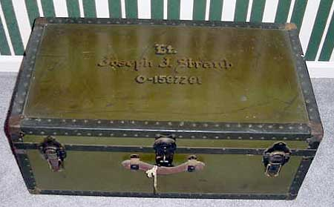
Example 2
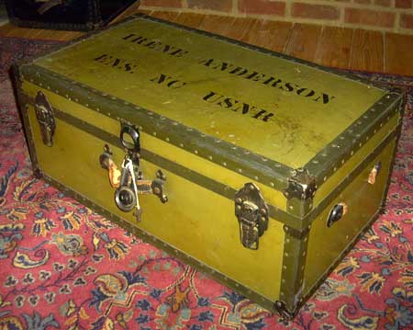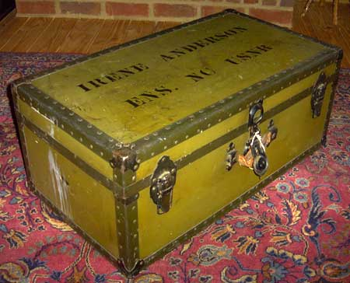
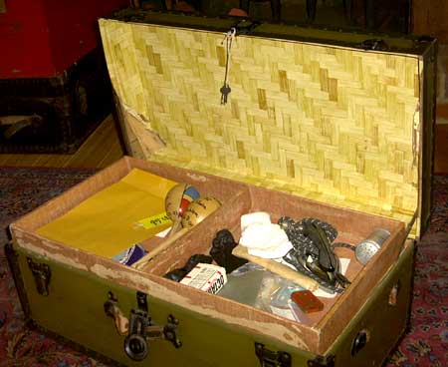
The tray has the original lining paper. The lid has been relined at some point in the footlocker's life.
Example 3
This example is a WW2 era footlocker. It was my father's trunk from when he was a kid. I think this is either very late war or just post war. You'll notice that the hardware & lining materials are very similar to the USNR trunk shown above.
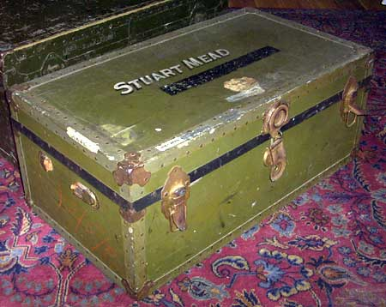
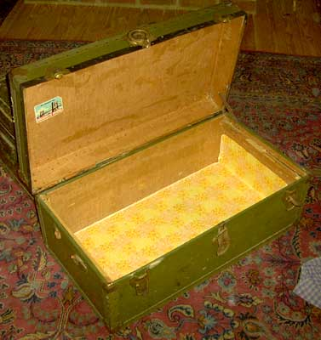
The lid & back side are the original lining. The bottom & right side are 1970's vintage shelf lining paper.

Model 1948 Footlocker (postwar)
This example was my father's footlocker when he was in the service between 1963-1993. The M1948 pattern replaced the leather handles with metal handles. This example is missing the dataplate, but I've seen other examples which still had the dataplate. You can see the original ligher green paint showing thru where the later dark green paint has worn off.
