World Geography 3rd 9 weeks Study Guide:
Maps:
1. What part of a map is used to find orientation?
2. What is the definition of a map?
3. What are the cardinal directions?
4. What are the intermediate directions?
5. What is the map legend used for?
6. What is used to find absolute location on a map?
7. What term is used to describe the location of a geographic feature in relation to other nearby features?
8. What part of a map is used to find the distance between two points?
9. What is the purpose of physical maps?
10. What is the purpose of political maps?
11. Why are all maps distorted?
12. What type of map projection is used by airline pilots?
13. What type of map projection is used by ship navigators?
Regions:
1. What country is the Taiga located in?
2. What type of climate zone do rainforests grow in?
3. Name three countries that have rainforests.
4. What two countries in Europe are called the 'Low Countries''?
5. What language unifies the region known as Hispanic America?
6. What language is spoken in Brazil?
7. What is the Francophone World?
8. What countries do Kurdish people live in?
9. What religion unifies North Africa and the Middle East?
10. What is the Rust Belt?
11. Why are regions important?
12. What are PUSH factors that cause people to leave? PULL factors that cause people to enter a new country?
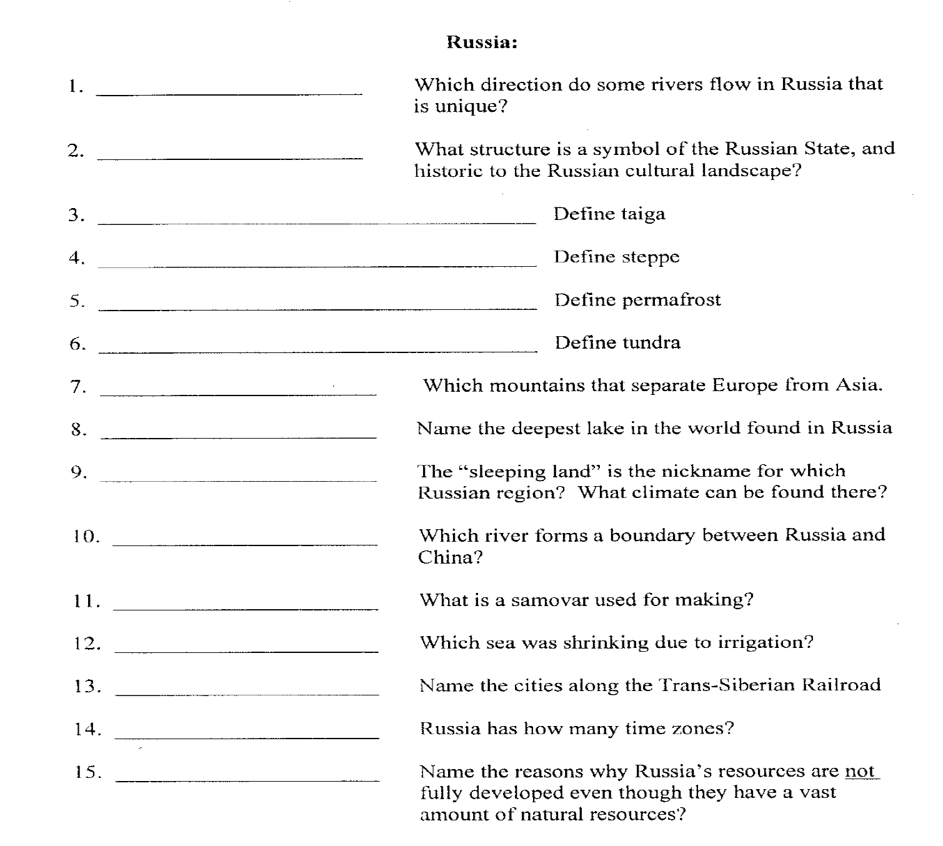

Europe:
1. The cultural building in England where Kings and Queens get married:
2. The_________________________began in Europe where humans used machines to help manufacture goods
3. In Sweden and Denmark the ________________________________plays a large part in their economy. This has often led to__________________________taxes.
4. This Italian river has seen the development of transportation due to its iron ore deposits:
5. Europe is very_________________________and has many different ________________groups
6. Windmills can be found in_______________________________________
7. The Parthenon can be found in______________________
8. The Leaning Tower of Pisa can be found in____________________________
9. Which important rivers can you find in:
A. France B. Germany C. Italy
10. What European country has little resources but has an established banking industry?
11. The Eiffel Tower, Arc de Triomphe and Notre Dame Cathedral are all cultural icons associated with________________________________.
12. Explain 3 ways Developed Countries differ from Developing Countries
A. B. C.
13. Rome is known for what cultural icon?
14. Europe as a whole is a developing // developed region (circle one)
15. The __________________________ is Europe’s longest river
16. Acid Rain is destroying the____________________________(HINT: Type Name of Forest)
17. What is the name of the political and economic organization formed by over 20 European Countries?
18. What is the name of the strait that separates the Atlantic Ocean from the Mediterranean Sean?
19. What city in Italy suffers mostly from water pollution?
20. Explain how Western European’s climate is milder than the rest of Europe?
21. What is a fjord? Where can you find them?
22. Which European city is closest to the Prime Meridian? (Hint: It is in Great Britain)
23. Castles can be found where?
24. What is the name of the infrastructure that connects England to France?
25. Define a polder. What country in Europe has them?
South America:
1. Mexico, Ecuador, and Venezuela all have vast_____________resources
2. Grasslands in South America are know and __________in the North and _________in the South
3. How have Mountains and Rainforests impacted economic growth in South America?
4. What country south of Florida has a dictator who dislikes the US?
5. Crowed housing and shantytowns are a result of _______________________
6. The primary language of South America is _________________
7. Which country speaks Portuguese?
8. The primary religion of South America is?
9. Which ancient civilizations lived at the following cities:
Tikal? Machu Picchu? Tenochtitlan?
10. What was the name of the former capital of Brazil?
11. In Peru you can find what Incan city?
12. In Mexico, you can find what Aztec city?
13. In Guatemala you can find what Mayan city?
14. People that are ½ European and ½ Indian are called____________
15. People that are ½ European and ½ African are called_____________
16. Mexico City is the largest city in___________________
17. In South America the seasons are____________
18. Which trade agreement lowered the tariffs between the US, Canada, and Mexico?
19. What is the name of the mountain chain that extends from the Northwest to the Southwest in South-America?
20. Puerto Rico is owned by__________________________
21. What is the name of the coastal desert in Chile?
22. In what climate zone can you grow citrus fruits, bananas, and rice?
23. Growing enough crops to survive is called____________________
24. What is the largest river basin in the world?
25. What is happening to the Rainforest?
26. What did Mexico create along the border of the US as a response to NAFTA?
27. Large family-owned ranching estates are called________________

