Europe-BEFORE and AFTER WW1
Directions: The political map of Europe changed dramatically as a result of WW1. Label each map below using page 475 in the textbook. Then answer the two questions at the bottom
EUROPE, 1920-COLOR and Label USING THE KEY
New Countries: Poland=Orange; Czechoslovakia=Green; Austria=Purple; Hungary=Pink; Yugoslavia=Yellow; Lithuania=Black; Latvia=Brown; Estonia= Blue, Finland=Red Dots
EUROPE, 1914
LABEL: France, United Kingdom, Germany, Italy, Russia, Austro-Hungary, Ottoman Empire
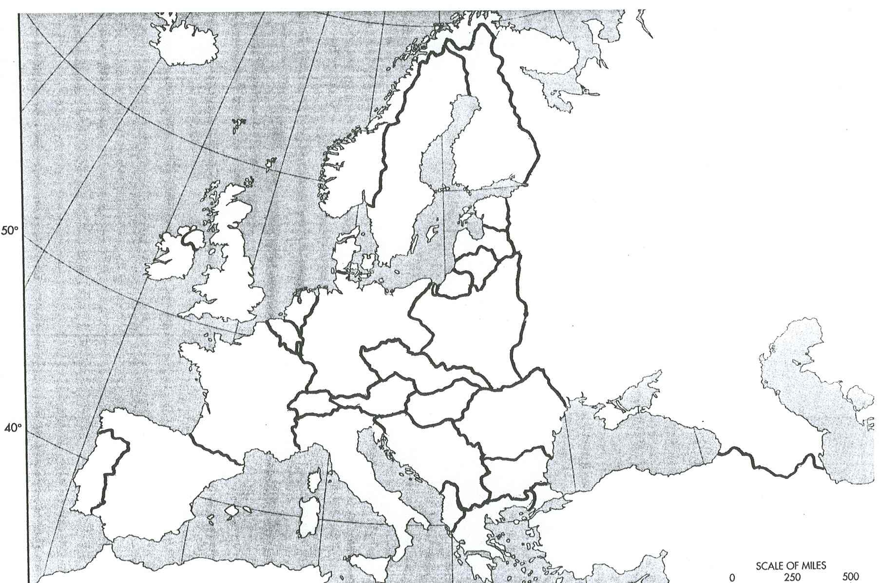
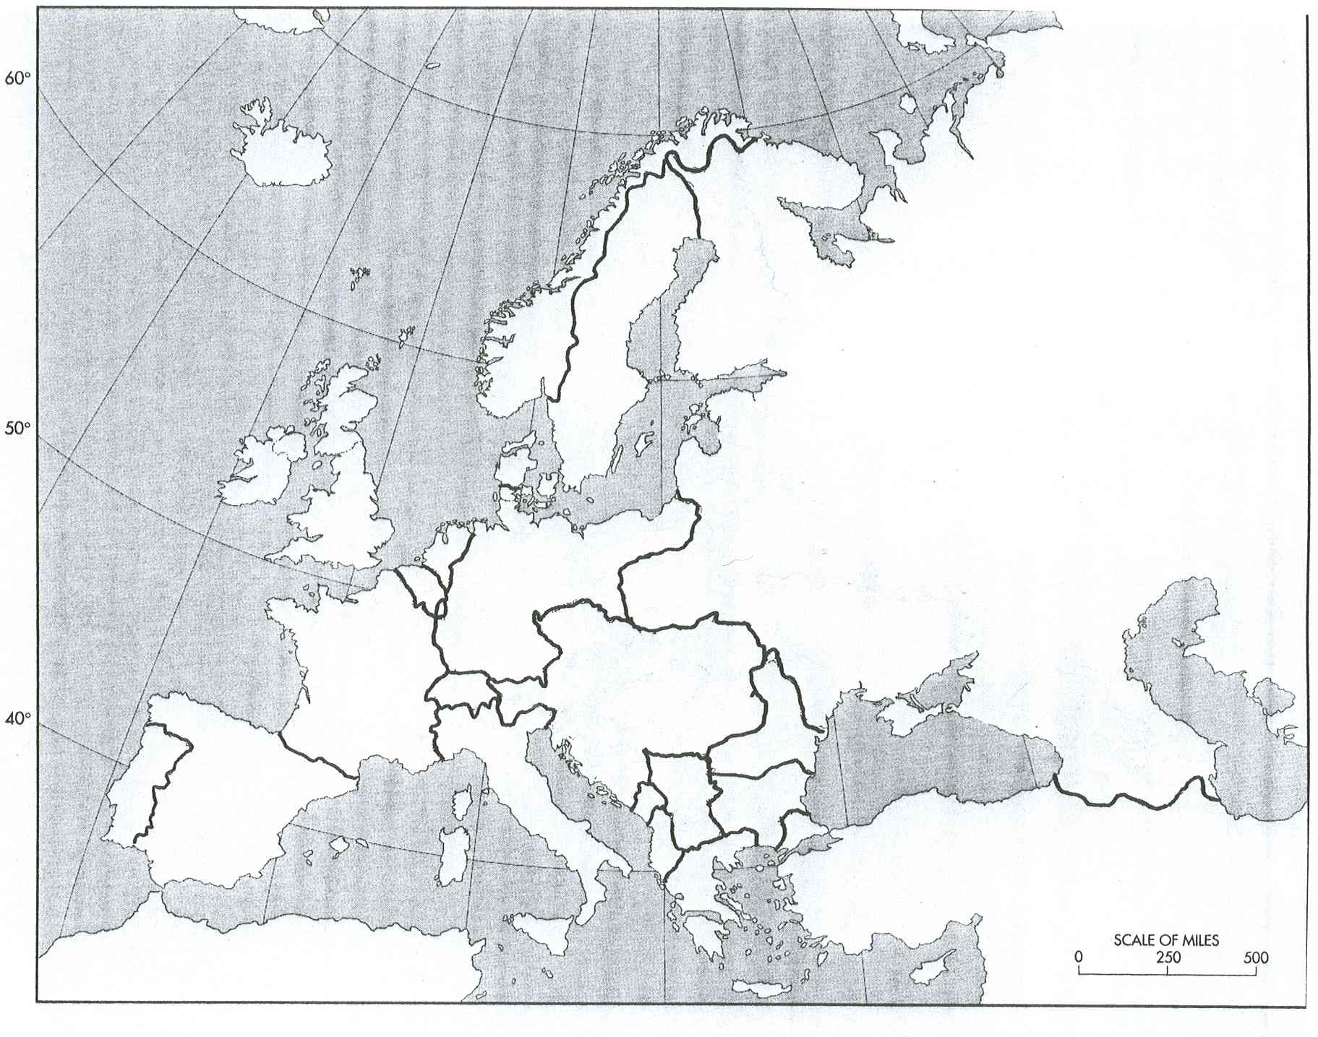
QUESTIONS 1. Which countries lost land (2)?
2. Which new countries were created (9)?
3. Which country broke-up after World War One (1)?
4. Why might Russia and Germany be upset? What do you think they might do in response?

