**Europe-BEFORE and AFTER WW1**

**Directions:** The political map of Europe changed dramatically as a result of WW1. Label each map below using page 475 in the textbook. Then answer the two questions at the bottom

**EUROPE, 1920-COLOR and Label USING THE KEY**

**New Countries:** Poland=Orange; Czechoslovakia=Green; Austria=Purple; Hungary=Pink; Yugoslavia=Yellow; Lithuania=Black; Latvia=Brown; Estonia= Blue, Finland=Red Dots

**EUROPE, 1914**

**LABEL:** France, United Kingdom, Germany, Italy, Russia, Austro-Hungary, Ottoman Empire

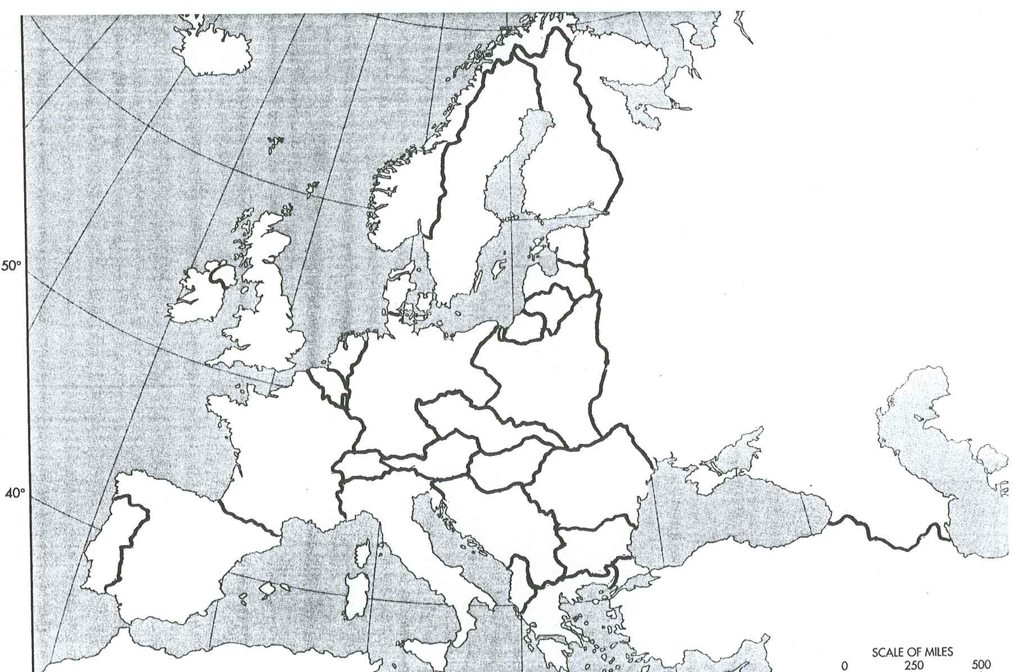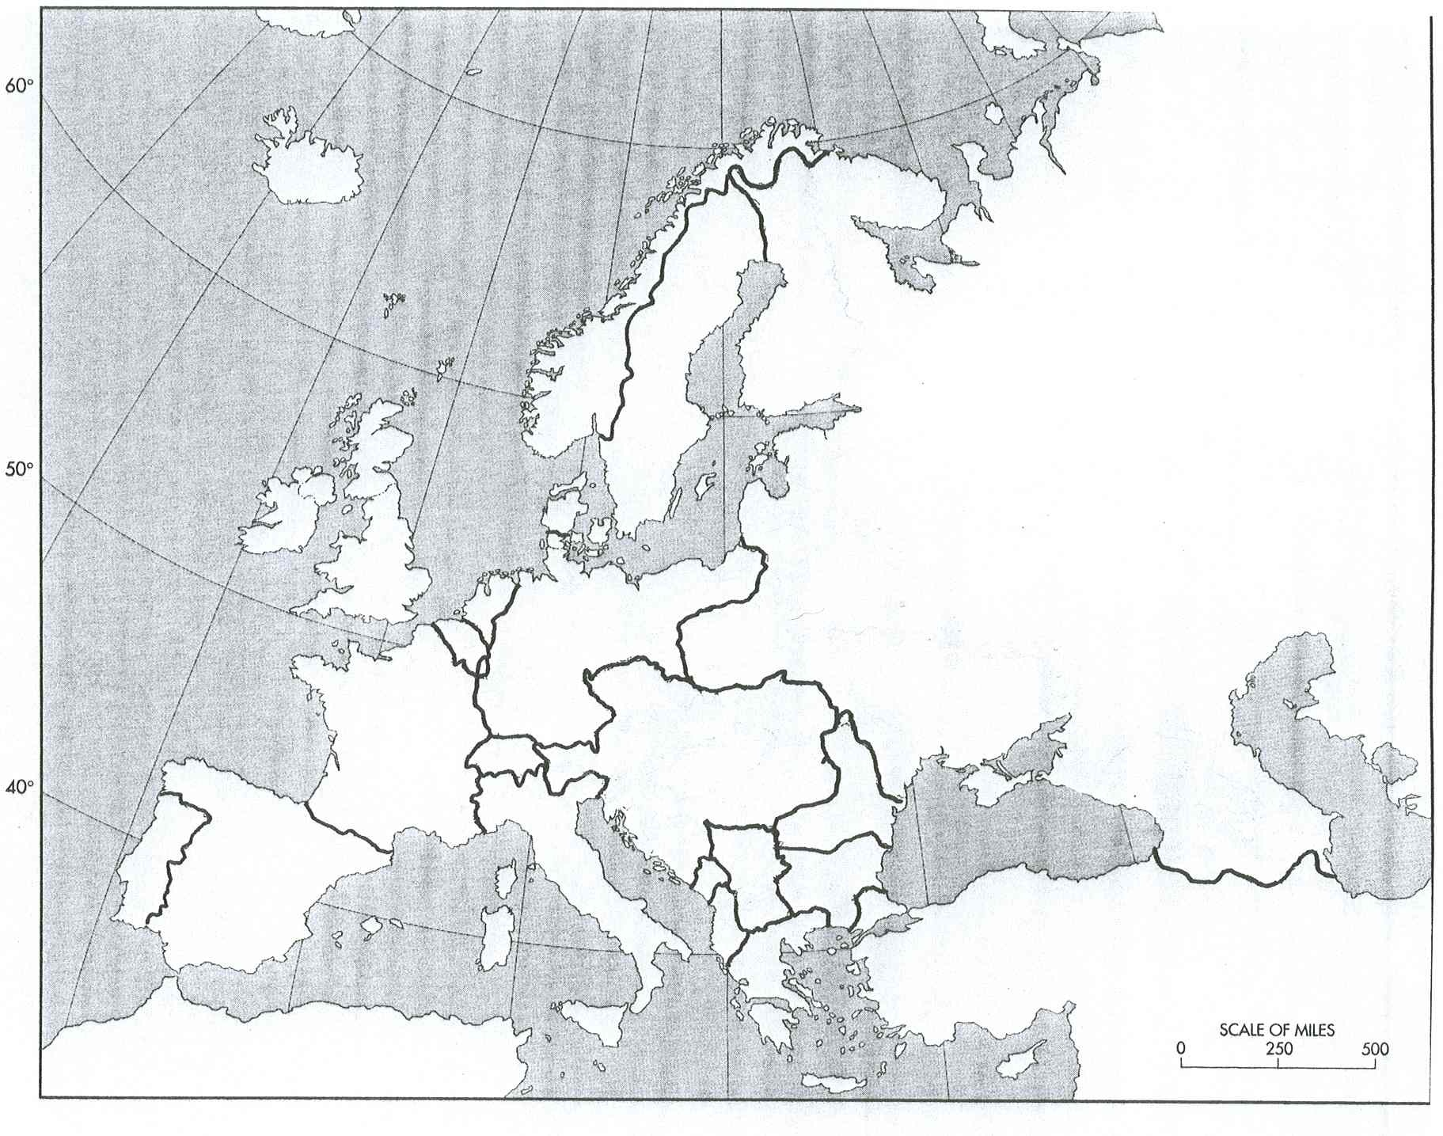

**QUESTIONS**  1. Which countries lost land (2)?

2. Which new countries were created (9)?

3. Which country broke-up after World War One (1)?

4. Why might Russia and Germany be upset? What do you think they might do in response?