Book V: World War I to Great Depression
Unit 1: World War I
Lesson 2: Trench Warfare

Topic Overview:

Word War I ushered in a new era of warfare. Major developments in strategy, tactics, weapons, and technology changed the way wars would be fought in the future. Germany used these new developments to advance to within thirty miles of Paris by September 1914. It seemed as though the Schlieffen Plan to subdue France would be successful. However, a combined British and French force stopped this advance at the First Battle of the Marne. They pushed the Germans back nearly sixty miles. At that point both sides dug into defensive positions. Nearly 500 miles of trenches stretched from Switzerland to the North Sea. Fighting on the Western Front in France had become a stalemate and both sides began to face a war of attrition.

Activity Overview:

In this recreation simulation students will act as soldiers on opposing sides to simulate the life and combat conditions in the trenches of World War I. They will recreate a battle in the classroom by conducting attacks with paper balls acting as both bullets and artillery shells.

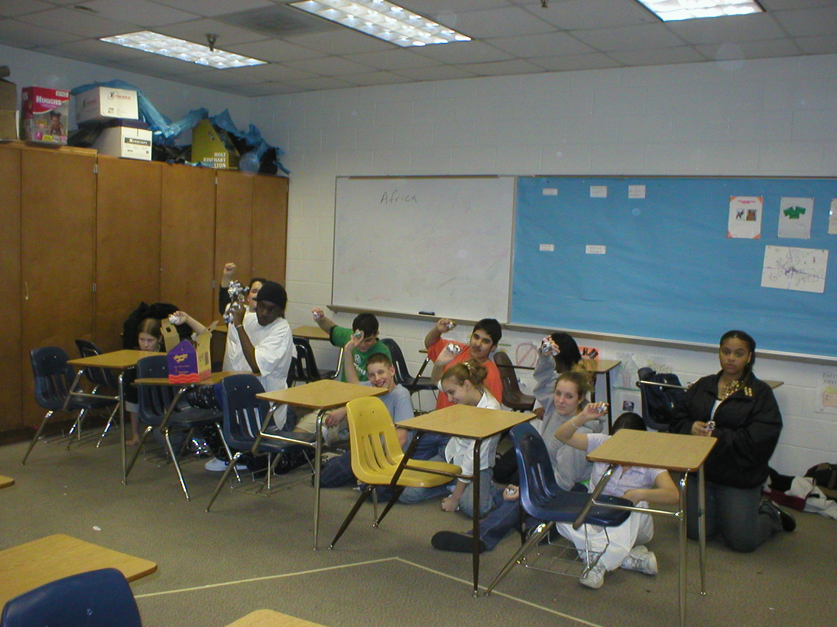
Objectives:
- Students will learn basic strategy, tactics, and weapons technology used in WW I.
- Students will recognize the horror and futility of trench warfare.
- Students will be able to define the term “stalemate.”

Setup:
- Align 2 rows of desks on opposite sides of the room according to the setup diagram. Students will crawl under the desks to seek cover. DO NOT allow them to jump over the desks.
- The open area between the 2 sides will be “no-mans-land.” Place a few desks there to serve as “bomb craters.”
- Display a large letter “A” on the wall above one side of the room and a large letter “B” on the other.
- Make 4 copies each of the WWI Machine Gun and the WWI Artillery. Attach a copy of the WWI Machine Gun each of 4 boxes. Attach a copy of the WWI Artillery to each of 4 other boxes.
- Make 6 volleyball-sized balls of paper (each side gets 3 each). These are the artillery shells.
- For the optional combat sequence, decorate the room with the optional materials. Make 2 volleyball-sized balls of yellow paper to symbolize gas.
- Make per student copies of the Objectives (half Defend and half Assault).
- Make per student copies of the Trench Warfare Worksheet.

Materials:
- Scrap paper or newspaper
- 8 medium-sized boxes
- Trench Warfare Worksheet (p.11)
- WWI Machine Gun Picture (p.12)
- WWI Artillery Picture (p.13)
- Objective of Assaulting Army (p.6)
- Objective of Defending Army (p.7)
Optional Materials:
  - Large flashlight for a flare during the night attack
  - CD player and battle sounds
  - Surgical masks to be used as gas masks
  - Fog machine for the gas attack
  - Strobe light for explosion flashes
  - Fake rats and roaches
  - Simulated barbed wire (material found at local arts and crafts stores)

Activity in Detail:
- Divide the class into 2 teams as they enter the room. Tell students to place their belongings off to the side of the room.
- Choose a student from each side to be that side’s General.
- Explain to students that they are going to recreate the trench warfare of WWI.
- Distribute and read the objectives and rules to the class. The object of this lesson is to show the futility of trench warfare. It is imperative that neither army is successful in capturing the enemy’s trenches. DO NOT reveal this to the class.
- Have each General choose 2 machine gunners and 2 artillerists.
- Demonstrate the whole process by having students do a walk-through assault without any paper being thrown. Follow these practice steps:
- Assaulting General: order the artillery barrage.
- Defending General: order return artillery fire.
- Assaulting General: give the “to your posts” command and then “cease fire.”
- Defending General: order troops into “firing trench” and wait for the assault.
- Assaulting General: give the “over the top” command and then start the assault by having the assaulting army line up in front of their trench in “no-mans-land.”
- When an assaulting army enters “no-mans-land” it can fire and be fired upon.
- If someone is hit with a piece of paper, they become a casualty and must lay down until the attack is over.
- Escort 1 student from the assaulting army through the enemy’s trenches to the flag (letter on the wall). Hand the flag to the student to show a victory.
- Have students make 5 paper balls each, and place 2 of them in the machine gun boxes and keep 3 for personal use.
- Before the assaults begin, describe the conditions of life in the trenches: mud, rusty barbed wire, muddy roads, caves, trench foot, rats, lice, extreme hot and cold.
- Have each General come to the center of “no-man’s land.” Flip a coin to see who will attack first. If time is short, only do 1 attack. (see the Optional Assaults).
- Carry out the daytime attack by starting the artillery barrage. One that has ended, wait 1 minute to start the infantry assault.
- Collect all the paper balls and set up for the next attack. Everyone is alive again.
- To heighten the feeling of actually being in a trench, have students role-play certain scenarios as they sit in the trenches. This is highly beneficial for students to internalize the experience.
- “Tell your neighbor about your loved one back home.”
- “How bad is your case of ‘trench foot?’”
- “If you were back at home, what would you be doing right now?”
- “What is the wounded German outside of your trench saying to himself?”
- Carry out the second attack if time permits.
- Clean up and have students complete the Trench Warfare Worksheet.

Debriefing:
- Explain that the goal of this activity was to show the futility of trench warfare.
  - “Were you able to capture the enemy’s flag? Why or why not?”
  - “How many on your side died when you were the assaulting army?”
- Read the following statistics on war losses:
- “Approximately 8.5 million men were killed; and twice as many wounded.”
- “Many were handicapped for life.”
- “Sometimes entire battles were fought for only a few hundred yards of territory
- “High casualties and poor leadership often led to extremely low morale among troops. For example, in the French cities of Arras and Champagne, 50,000 French soldiers refused to fight because they saw the futility in trench warfare and were disheartened by poor leadership, so 23,000 of them were court-martialed and 432 were given the death sentence.”
- Define “stalemate:” as a situation in which neither side can win. Use the game of chess to illustrate this concept. Ask students: ”why would you consider trench warfare a stalemate?”
- Have students complete the Trench Warfare Worksheet.

Assessment:
- Trench Warfare Worksheet
- Essay Question: Describe the conditions of Trench Warfare and why there were so many casualties.
Objective of Assaulting Army
Advance across “no-man’s-land” and capture the enemy trenches.
Capture the enemy’s flag (A or B) to show that you have captured the trench.

Rules for Assaulting Army
- Follow your General’s orders. You will be shot if you do not follow orders.
- The General’s orders are:
  - to start the artillery barrage
  - for you to go to the “firing trench” by saying “to your posts”
  - to cease the artillery barrage
  - to start the assault by saying “over the top”
- To assault, crawl through the spaces in between the desks, cross “no-mans-land,” and defeat the enemy by securing their flag.
- You cannot fire until you are in “no-mans-land.”
- If you do not leave the trench you will be considered a coward and will be shot by your own General. Therefore, the only chance you have at surviving is to safely cross “no-mans-land” and take the enemy’s trench.
    - Infantrymen:
        - Everyone but artillerymen and the General are infantrymen.
        - You each get 3 balls of paper as ammunition to throw at the enemy.
- Machine Gunners:
  - You can use 1 box of 30 paper balls for ammunition.
  - You can only fire as a machine gun in DEFENSE. However, you can act like any other infantryman when your team is attacking.
- Artillerists:
  - You may only fire when ordered to by your General.
  - Use the boxes with the large balls as ammunition.
  - The General will tell you to “cease fire” just before the assault commences.
    - Casualties: If you are hit with a paper ball, you become a casualty and must lie down until the assault is over.
Objective of Defending Army
Stop the assaulting army from taking your trench (capturing your flag) by hitting them with paper balls.

Rules for Defending Army
- Machine gunners will be the only students in the “firing trench.” All others are to be in the “cover trench.”
- After the assaulting army begins its artillery barrage, your General has the option of either returning artillery fire right away or waiting until the assault begins.
- After the enemy artillery barrage ends you will be commanded by your General to go to the “firing trench” and wait for the assault that will be coming.
- You CANNOT fire on the enemy until you are commanded to do so by your General or you will be disqualified.
- Machine Gunners:
  - You can only fire in DEFENSE.
  - You can use 1 box of 30 paper balls for ammunition
- Artillerists:
  - You may only fire upon receiving orders from your General.
  - You will remain artillerists during the entire activity.
  - Use the boxes with the large balls as ammunition.
- Infantrymen:
  - The rest of the students on your side are considered infantrymen.
  - You each get 3 balls of paper as ammunition to throw at the enemy.
- Casualties: If a paper ball hits you, you are considered a casualty and must lie down until the assault is over.
Optional Assaults:
- Gas Attack (best done during the artillery barrage):
- Use the yellow paper balls or a fog machine to simulate poison gas. Student wear the surgical masks as a mock gas mask. Have them keep the masks in their pockets initially.
- Throw the yellow balls into the trenches (or engage the fog machine).
- To survive, students must put on their gas mask correctly within 5 seconds.
- Interject information about the physical effects of chlorine gas.
- Point out those students who failed to wear their gas masks correctly.
- Night Assault:
- Cover windows to decrease light (ensure enough light for safety reasons).
- Tell the Assaulting Army General order troops sneak across “no-mans-land” in order to surprise the defending army and gain the tactical advantage.
- Discuss life in the trenches at night (i.e. rats, roaches, artillery barrages, etc.)
- The defending army cannot start to fire until the “flares” (a flashlight) go off and light the battlefield.
- When the assaulting army has crawled into “no-mans-land,” turn on the “flare.”
- Have the lights flicker and flash to simulate gunfire.
Trench Warfare Worksheet

- Describe a soldier’s life in the trenches.

- In trench fighting, how did a battle progress?

- In what ways were soldiers wounded / killed in trench warfare?

- Describe the advantage of a machine gun over a single-shot rifle.

- Define “stalemate.”

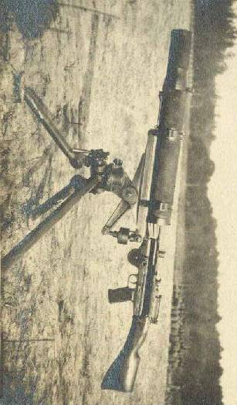
WWI Machine Gun Picture
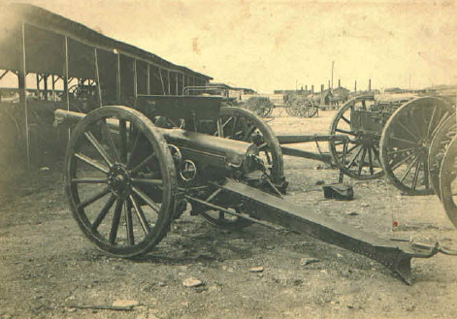
WWI Artillery Picture

