**All Quiet on Western Front.**  
 This film was made in 1930 and won best picture in the same year. The film is based on the book of the same name written by Erich Maria Remarque. The book (and the film) is about the influence of World War One on the lives of German soldiers.

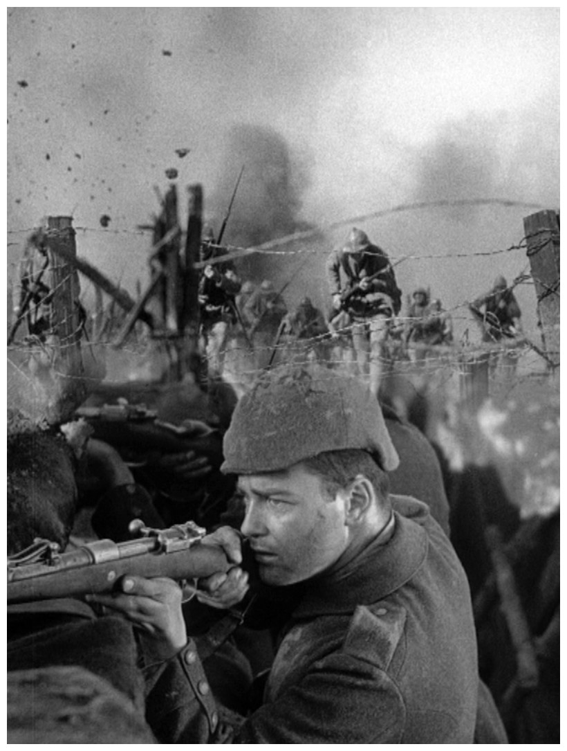

**Characters:**

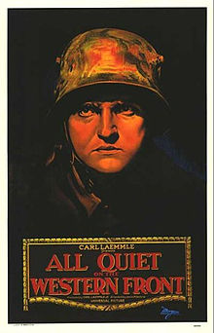

Paul Baumer: Main German soldier

Stanislaus Katczinsky “Kat”: Paul’s friend

HimmselStoss: Training Officer

Professor Kantorek: Paul’s teacher

Franz Kemmerich: Paul’s friend

Albert Kropp: Paul’s friend

Mueller: Paul’s friend

Tjaden: Paul’s friend

**Viewing Questions**

1. Why did the students join the Army?
2. What role did the mailman (Himmelstoess) have? Was he particularly mean to these recruits? Give an example.
3. How were conditions at the Western Front different from their expectations in training camp?
4. What was the impact of the shelling on the new recruits?
5. What happened after the bombardment?
6. In the attack, what did the machine gun do to the glory of war and individual heroism?
7. How many of the company died in this first battle? How do you know? Why were they able to eat so well finally?
8. Who did they blame for this war?
9. What happened to Kemmerich's boots? How did the doctors' react to Kemmerich's plight?
10. How was Sgt. Himmelstoess received when he arrived at the front?
11. What was the pattern of a battle? What preceded the attack? What followed it?
12. What happened to Paul Baumer when he found himself in a shellhole in No Man's Land with the French soldier?
13. After four years of war, how has the German homefront been affected? Were there still the parades, crowded streets, and joyous sounds of going off to war?
14. What were the attitudes of the men in the beer hall? Were they willing to listen to what Paul had to say?
15. How does Paul Baumer confront his former teacher? How do the young students react to his vision of the war?
16. How has the company changed during Paul's absence?
17. What is ironic about Kat's and Paul's deaths? [Note: The war ended on November 11, 1918.]
18. Describe the attitude of this movie towards World War I and all wars.

**Discussion Questions**

1. During the battle scenes, did you want the Allied soldiers to win or did you want Paul and his German friends to win? Why?

2. Most people believe that it's a good thing to be patriotic. The young men shown in this movie were motivated by patriotic feelings to enlist in the German Army. What does this story tell us about patriotism?

3. Were Paul and his friends courageous? Was any one of them a coward?

4. What does Paul's sympathy and concern for the dying enemy soldier demonstrate?

5. When should the value of caring for another human prevail over the dictates of war?

6.  Explain a better way for Paul to have helped his country other than to go to war: