World Geography Study Guide

1. What body of water has shrank over time due to water diversion?
2. Where can you find polders?
3. After the Cold War ended what former country broke-up and suffered ethnic conflict?
4. Name 3 things the Aswan High Dam does:
5. Canals, Reservoirs, and Irrigation ditches all help divert what resource?
6. Taiwan believes itself to be independent from what country?
7. Name an example of a capital resource?.
8. What are some reasons nations/states cooperate with each other?
9. What is the culture alliance that consists of countries of the former British Empire?
10. NATO is what kind of alliance?
11. What kind of vegetation might you find in the Taiga?
12. What region of Canada has cultural ties to France?
13. What is NAFTA?
14. Name 3 factors that PUSH people to migrate (leave) from one country to another?
15. Name a factor that influences Population Distribution
16. How are some ways humans change the environment.
17. Give an example of a natural resource
18. Name 3 characteristics of the Human Population
19. Name 2 factors that link or divide regions?
20. What city in the middle east is home to Jews, Christians, and Muslims?
21. In the Sunbelt region of the US you can expect to find high or low temperatures?
22. What invention caused people to live in suburbs instead of cities?
25. In India, what two religious groups often have conflict?
26. Chinatowns and Kurdistan are based on what kinds of similarities?
27. On which continent can you find the Sahara Desert?
28. What is the cultural and economic region that describes 26 countries unified around a single currency called the Euro?
29. Where is desertification a problem?
30. Chernobyl Meltdown is an example of what kind of pollution?
31. What is a problem with the use of fertilizers?
32. NATO is an example of what kind of Alliance
33. Why do humans create political divisions?
34. What kind of organizations are the Red Cross and Red Crescent
35. Which country does Syria fight with over control of the Golan Heights?

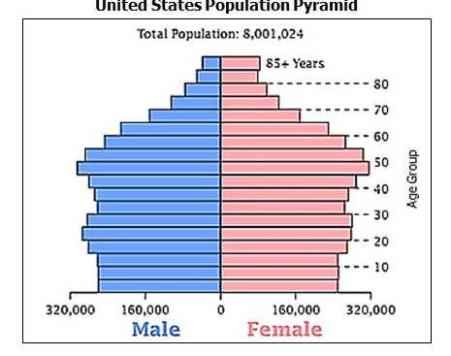
36. Looking at the population pyramid at the left:
A. What do the numbers along the bottom represent?
B. What do the numbers along the side represent?
C. Approximately how many 70-year old females are there?
D. Which age group of males are there the fewest?

